

## Deccan Education Society’s

**Willingdon College, Sangli**

**(Autonomous)**

**A**

**PROJECT REPORT**

**ON**

**“Attendence Management System”**

## Submitted to

**Shivaji University, Kolhapur**

## In the partial fulfillment of the degree of

**B.Sc. Computer Science [Entire]**

**By**

**Mr. Prathmesh Prakash Pawar.**

**&**

**Mr. Vikas Abasaheb Bhosale.**

**Under the Guidance of**

**Miss A.A.Kulkarni**

**Academic Year: 2024-25**



## Deccan Education Society’s

**Willingdon College, Sangli**

**(Autonomous)**

**CERTIFICATE**

This is to certify that the project entitled **“Attendence Management System”** submitted by **Mr. Prathmesh Prakash Pawar.** and **Mr. Vikas Abasaheb Bhosale.** in partial fulfillment of the requirement of the award of degree ***B.Sc. Computer Science [Entire]*** to Shivaji University, Kolhapur has been carried out by them under my guidance satisfactorily completed during the academic year 2024-2025.

Place : Sangli

Date :

**Miss A.A.Kulkarni Dr. V. S. Patil**

Project GuideCoordinator

Dept. of B. Sc. Computer Science [Entire]

Examiner: 1.____________________________

2.____________________________

**DECLARATION**

To,

The Principal,

Willingdon College,

Sangli.

Respected Sir,

We undersigned hereby declare that the project entitled **“Attendence Management System”** developed under the guidance of **Miss A.A.Kulkarni.** The reports generated in the project work are based on the information collected by us.

We have not copied from any other project report submitted to Shivaji University, Kolhapur earlier.

Place : Sangli

Date :

**Mr. Prathmesh Prakash Pawar. (Roll No. 71)**

**Mr. Vikas Abasaheb Bhosale.** **(Roll No. 08)**

**ACKNOWLEDGEMENT**

It gives us great pleasure to express gratitude to **Miss A.A.Kulkarni** for his valuable guidance and suggestion while preparing this project.

We are thankful to ***Dr. V. S. Patil***, Coordinator, Department of B. Sc. Computer Science [Entire], Willingdon College, Sangli for making available all the required resources and kind co-operation in our project work.

I wish to express my sincere thanks to ***Prof. Dr. S. S. Sawant****,* I/C Principal, Willingdon College, Sangli, all teaching and non-teaching staff of Department of B. Sc. Computer Science [Entire] for their extraordinary help throughout period of my project. We are also thankful to those who helped us directly-indirectly in completion of this works successfully.

Place : Sangli

Date :

**Mr. Prathmesh Prakash Pawar. (Roll No. 71)**

**Mr. Vikas Abasaheb Bhosale. (Roll No. 08)**

**INDEX**

1. Introduction to Project 1

1.1 Statements Of The Problem 2

1.2 Existing System 3

1.3 Need and Scope of Computer System 5

2. Proposed System 6

1) Objective 7

2) Requirment Engineering 8

* Software Requirement Specification (SRS)
* Software requirement – C#.NET/ASP.NET 9
* Database requirement - SQL Server 12

3. System Analysis 15

3.1 Data Flow Diagram 16

3.2 Entity Relationship Diagram 21

3.3 UML (if applicable) 22

4. System Design 23

4.1 Data Base Design 24

4.2 Input Design 28

4.3 Output Design 34

5. Implementation 45

5.1 System Requirement 46

* + Hardware
  + Software

5.2 User Guideline (User Manual) 47

6. Outputs 51

* Screens and Reports (with valid Data)

7. Conclusion & Future Enhancement 63

* Conclusion
* Limitation (Future Enhancement)
* Suggestions

8. Bibliography 66

**Synopsis Work :-**

**Proposed Tittle: Attendance management system**

**Student Name: Prathmesh Prakash Pawar Roll No:71**

**Student Name: Vikas Abasaheb Bhosale Roll No:08**

**Guide Name: A.A.Kulkarni**

**1.Relevance[Overview of Project Work]**

* Introduction
* Organizational Profile(If Application)
* Exiting System
* Limitation

**2.Proposed Work:**

* Introduction[Working Principle]
* Modules to be implemented
* Implementation Steps

**3.Testing of Software**

All the modules tested manually

**4.Facility Available**

* **Hardware Requirement**
* **Front End Tool:**Microsoft Visual Syudio 2012()
* **Back End Tool:** My SQL/Microsot SQL Server 2005

**5. Scope of the project**

**6.References**

Google, YouTube

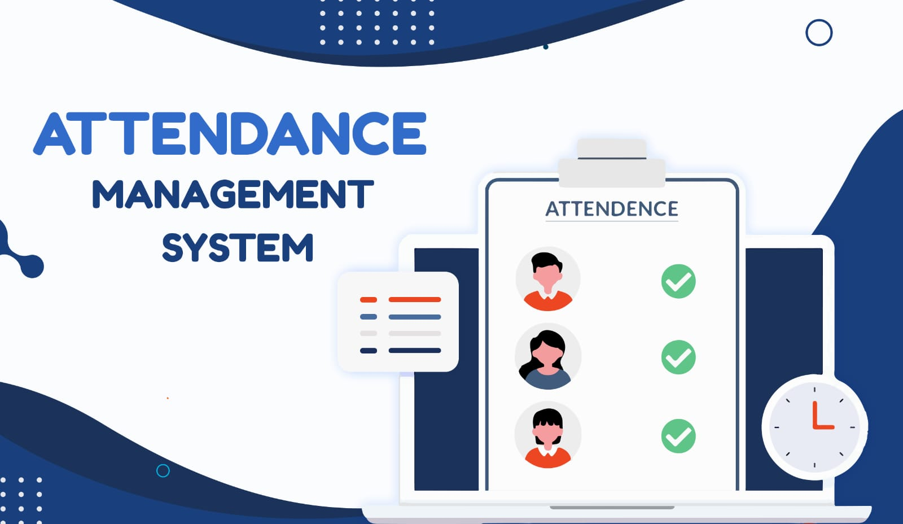

**Introduction to project :-**

The Attendance Management Portal is a comprehensive system designed to streamline the process of tracking and managing attendance within an educational or organizational setting. It features three distinct login types—Admin, Staff, and Student—each tailored to specific roles and responsibilities. The Admin login is designated for principals or heads of institutions, allowing them to manage divisions, add staff members, and configure various system components.

Staff members can log in to register student details, mark attendance as present or absent, and oversee student records efficiently. Meanwhile, students have their own login access to view their attendance reports, file complaints, and submit leave requests. This structured, role-based access ensures smooth communication and efficient management of attendance-related activities across the institution. It cans simply overall examination management and result generation activity.

**Existing System :-**

In most schools and colleges, attendance is traditionally managed through manual methods such as paper-based registers or Excel sheets. Teachers or staff members mark students' attendance daily, maintaining physical records that are later compiled for reporting purposes. In some institutions, basic digital systems are used, but they often lack integration, automation, and real-time access for students and administrators. These systems are time-consuming, prone to human error, and require considerable effort for data management, especially when handling large numbers of students.

**Limitation :-**

* Time-Consuming Process: Manual attendance takes significant time, especially in large classes.
* Prone to Human Errors: Errors in marking, recording, or compiling attendance data are common.
* Data Inconsistency: Difficulty in maintaining accurate, consistent, and easily retrievable records.
* Lack of Real-Time Updates: Students and parents cannot access attendance reports instantly.
* Risk of Proxy Attendance: Manual systems are susceptible to proxy or false attendance marking.
* Inefficient Leave Management: No streamlined process for students to request or track leave.
* Limited Reporting Capabilities: Generating detailed attendance reports is tedious and slow.
* Security Issues: Physical records can be easily lost, damaged, or tampered with.

**Proposed System :-**

To address the limitations of the existing system, we propose an Online Attendance Management Portal designed to automate and streamline attendance processes. This portal features three distinct logins—Admin, Staff, and Student—ensuring role-based access for efficient management. The Admin login is designated for principals or heads of institutions, allowing them to add divisions, manage staff, and configure system components. Through the Staff login, teachers can easily add student details and mark attendance as present or absent with just a few clicks. The Student login enables students to access their attendance reports in real-time, submit leave requests, and file complaints when needed.

This system reduces administrative workload, minimizes errors, and enhances data security. It also ensures real-time updates, transparent reporting, and an efficient leave management process, making attendance tracking more reliable and accessible for all stakeholders.

**Modules :-**

**1. Admin Module**

* Admin (Principal/Head) login authentication
* Add and manage divisions, staff, and system components
* View and manage student and staff attendance records
* Generate attendance reports and analytics

**2. Staff Module**

* Staff login authentication
* Add and manage student details
* Mark student attendance (present/absent)
* View and edit attendance records
* Generate reports for students' attendance

**3. Student Module**

* Student login authentication
* View personal attendance reports
* Submit leave requests for approval
* File complaints related to attendance issues
* Receive notifications regarding attendance status

**4. Attendance Management Module**

* Real-time attendance tracking
* Automated calculations for attendance percentage
* Exportable reports for admin and staff

**5. Leave Management Module**

* Students can submit leave requests
* Staff/Admin can approve or reject leave requests
* Leave status tracking by students

**6. Complaint Management Module**

* Students can file attendance-related complaints
* Admin/Staff can review and respond to complaints
* Status tracking for complaint resolution

**7. Reporting & Analytics Module**

* Generate student-wise and class-wise attendance reports
* View monthly and yearly attendance trends

**Hardware Requirement :-**

1. Processor: intel core
2. Memory: 8 GB Ram
3. Hard disk: 20 GB

**Software Requirement :-**

1. Front end: .net
2. Back end: MY-SQL server
3. Operating system: Window 11
4. Browser: goggle chrome/ Microsoft edge
5. IDE: visual studio 12

**Scope :-**

The Software Requirements Specification contains all the requirements of our system Attendance Portal. This is developed to fill up online attendance through internet with Attendance Portal System.

Staff fill up online attendance. This system also works to generate report of student attendance. Student can also view his report online. Student can also make a leave online. Student can also make a complain online. Staff and student have their username and password.

**Objectives :-**

Attendance portal is software developed for maintaining the attendance of the student on the daily basis in the school. Here the staffs, who are handling the class, will be responsible to mark the attendance of the students. Each staff will be given with a separate username and password for make attendance. If student make the leave staff get the notification on his mobile. Student also make complain to staff online. An accurate report based on the student attendance is generated here. Report of the student’s attendance on weekly and monthly basis is generated.

**E-R Diagram :-**

E-R (Entity-Relationship) Diagram is used to represents the relationship between entities in the table.

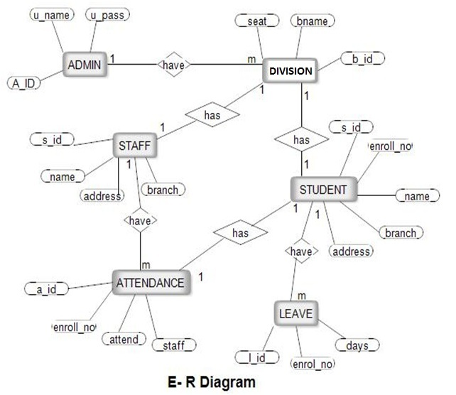

**Data Flow Diagram :-**

A data flow diagram (DFD) is a graphical representation of the "flow" of data throughan information system, modeling its process aspects. A DFD is often used as a preliminarystep to create an overview of the system, which can later be elaborated.[2] DFDs can alsobe used for the visualization of data processing .A DFD shows what kind of information will be input to and output from the system, wherethe data will come from and go to, and where the data will be stored. It does not showinformation about the timing of processes, or information about whether processes willoperate in sequence or in parallel .

1. **Context level data flow diagram**

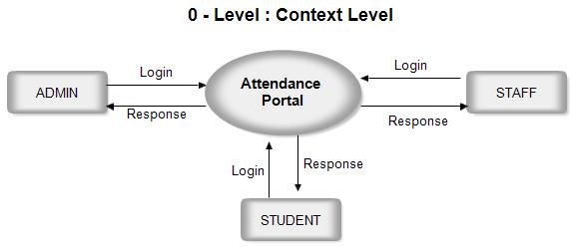

1. **Data flow diagram for admin**

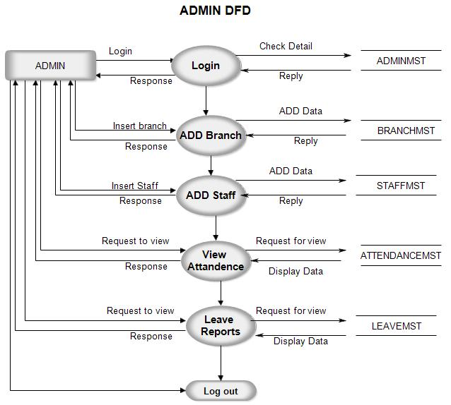

1. **Data flow diagram for student**

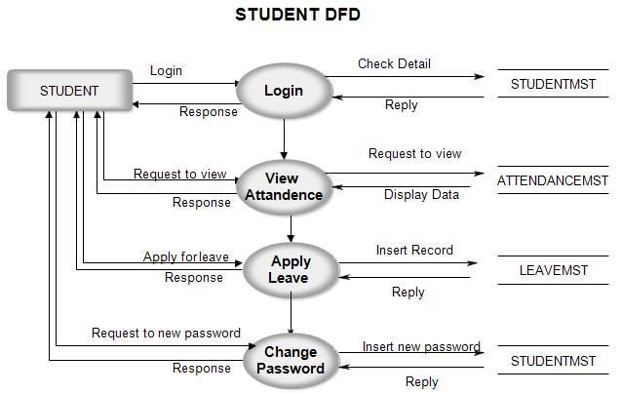

1. **Data flow diagram for staff**

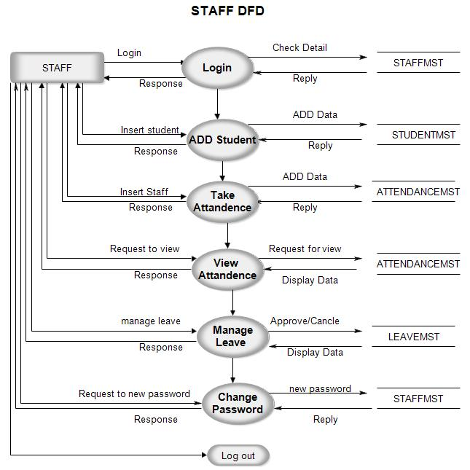

**Data Dictionary :-**

1. BranchMst :-

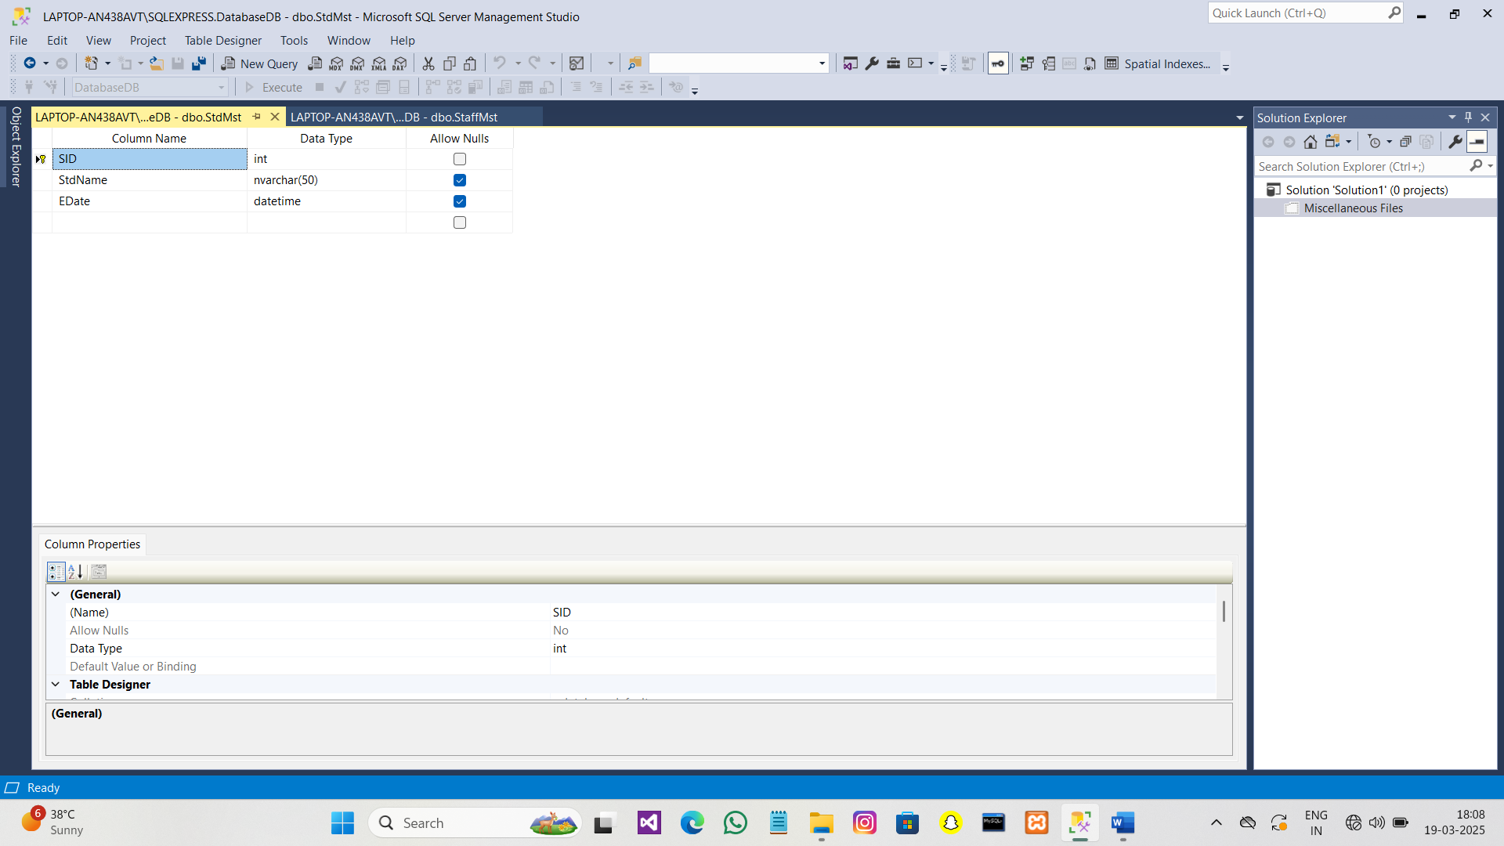

2. AttandanceMst :-

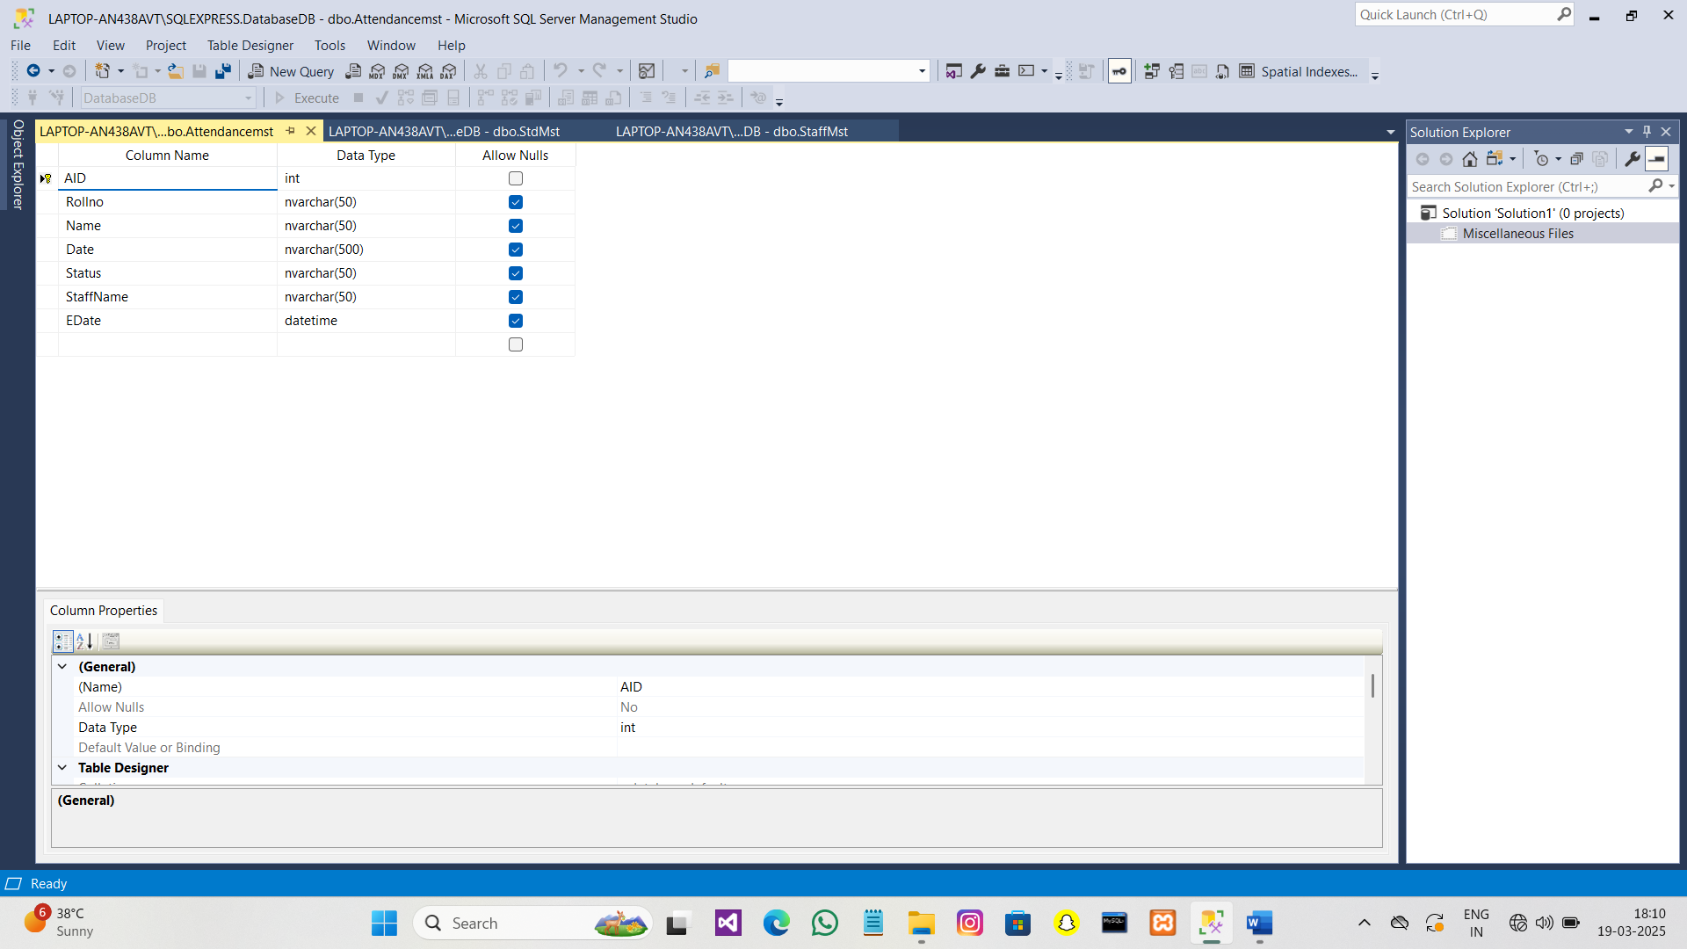

3. ComplainMst :-

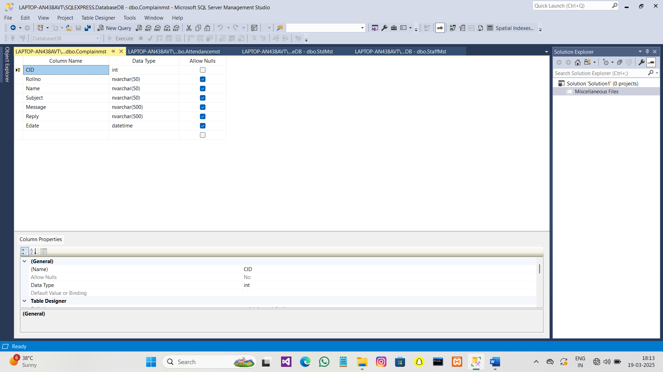

4. LeaveMst :-

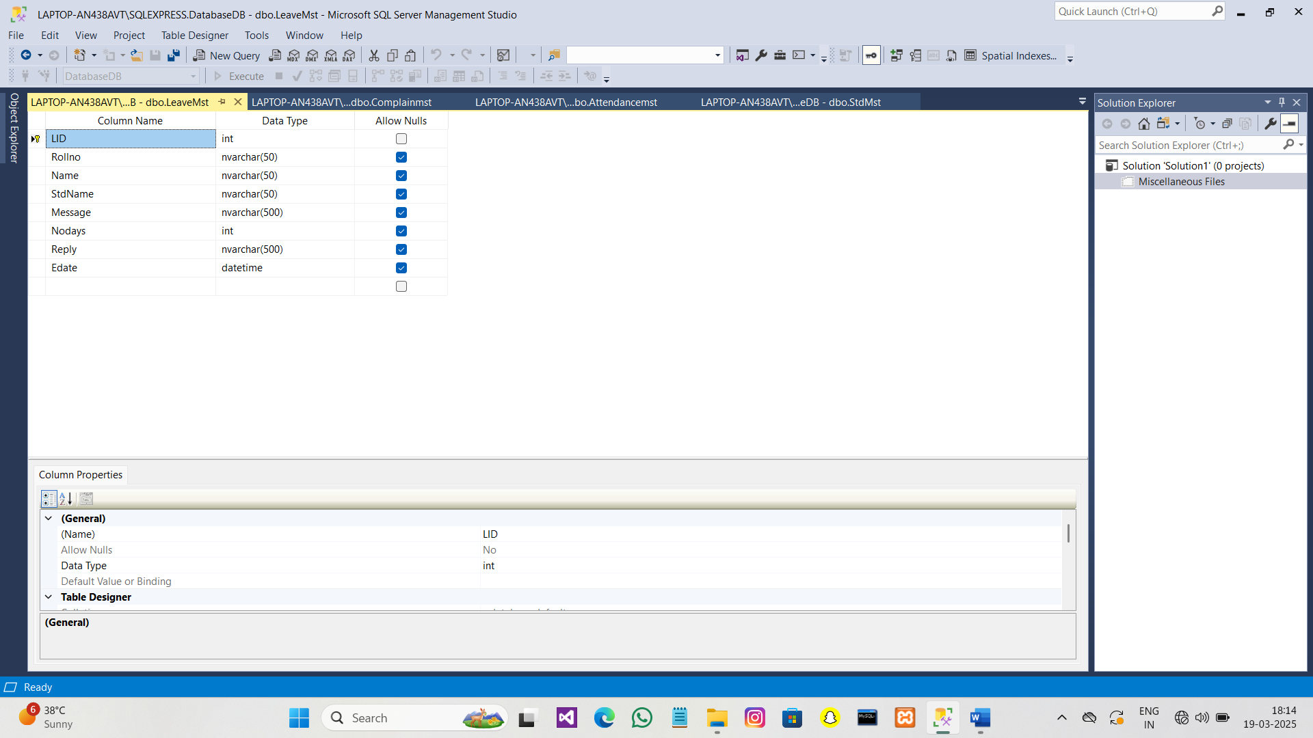

5.StaffMst :-

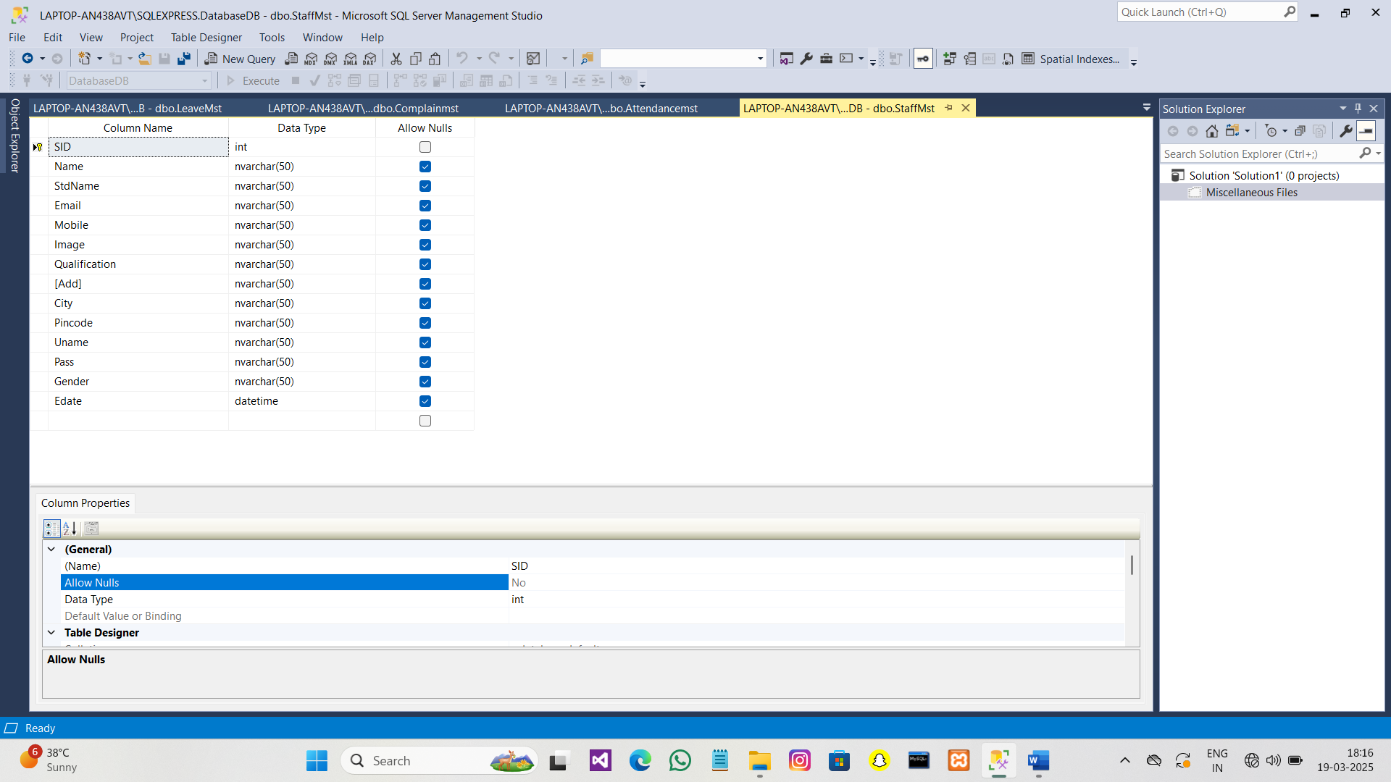

8.FeedBack_mst **:-**

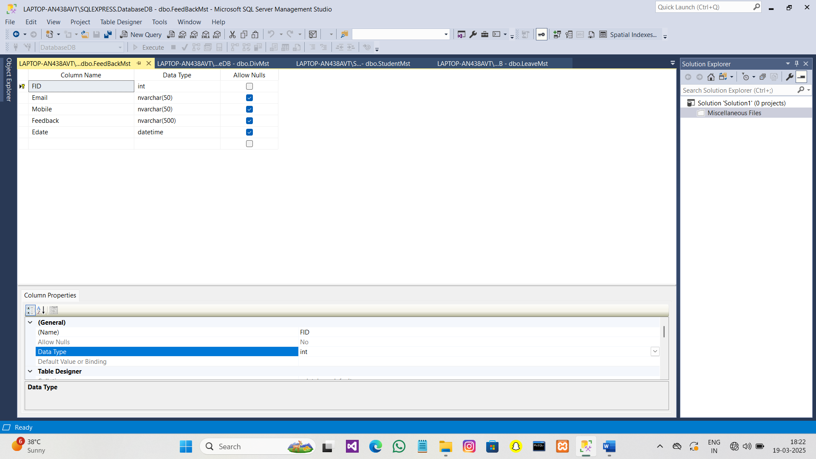

7.StudentMst

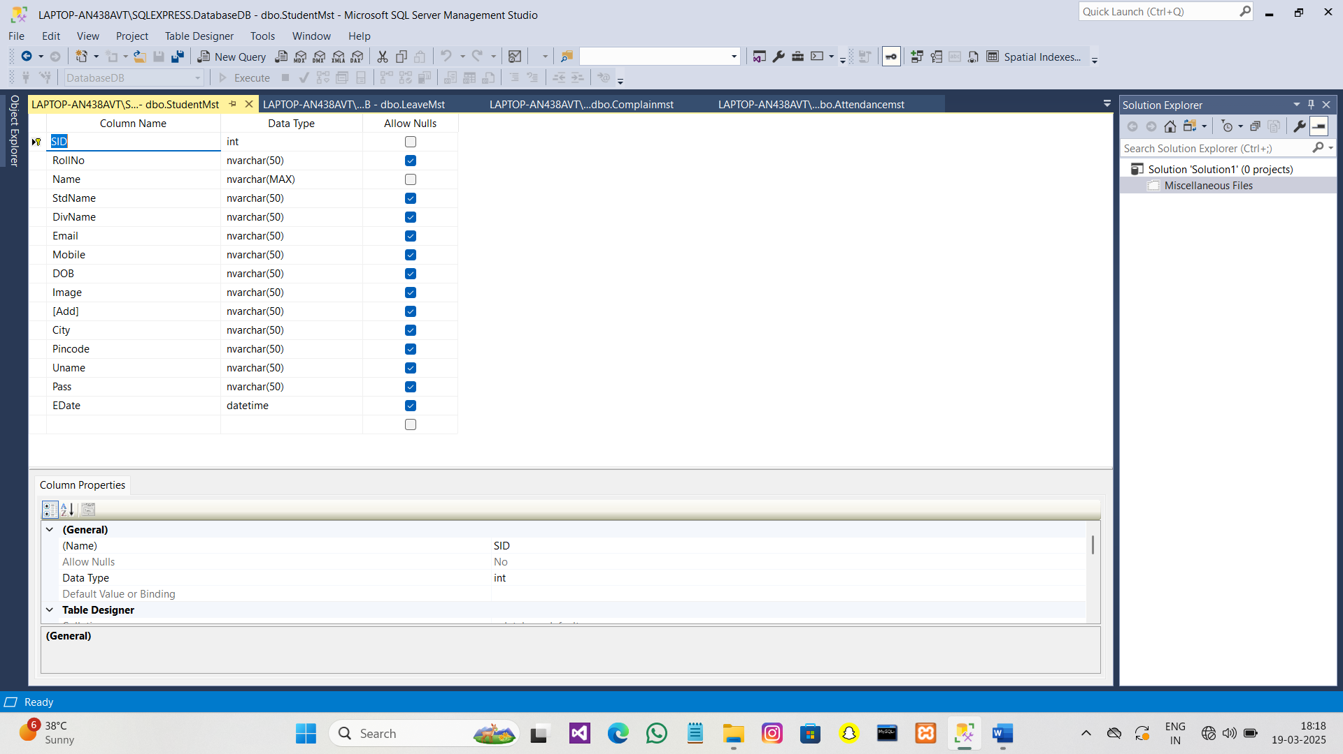:-

8.Div _mst

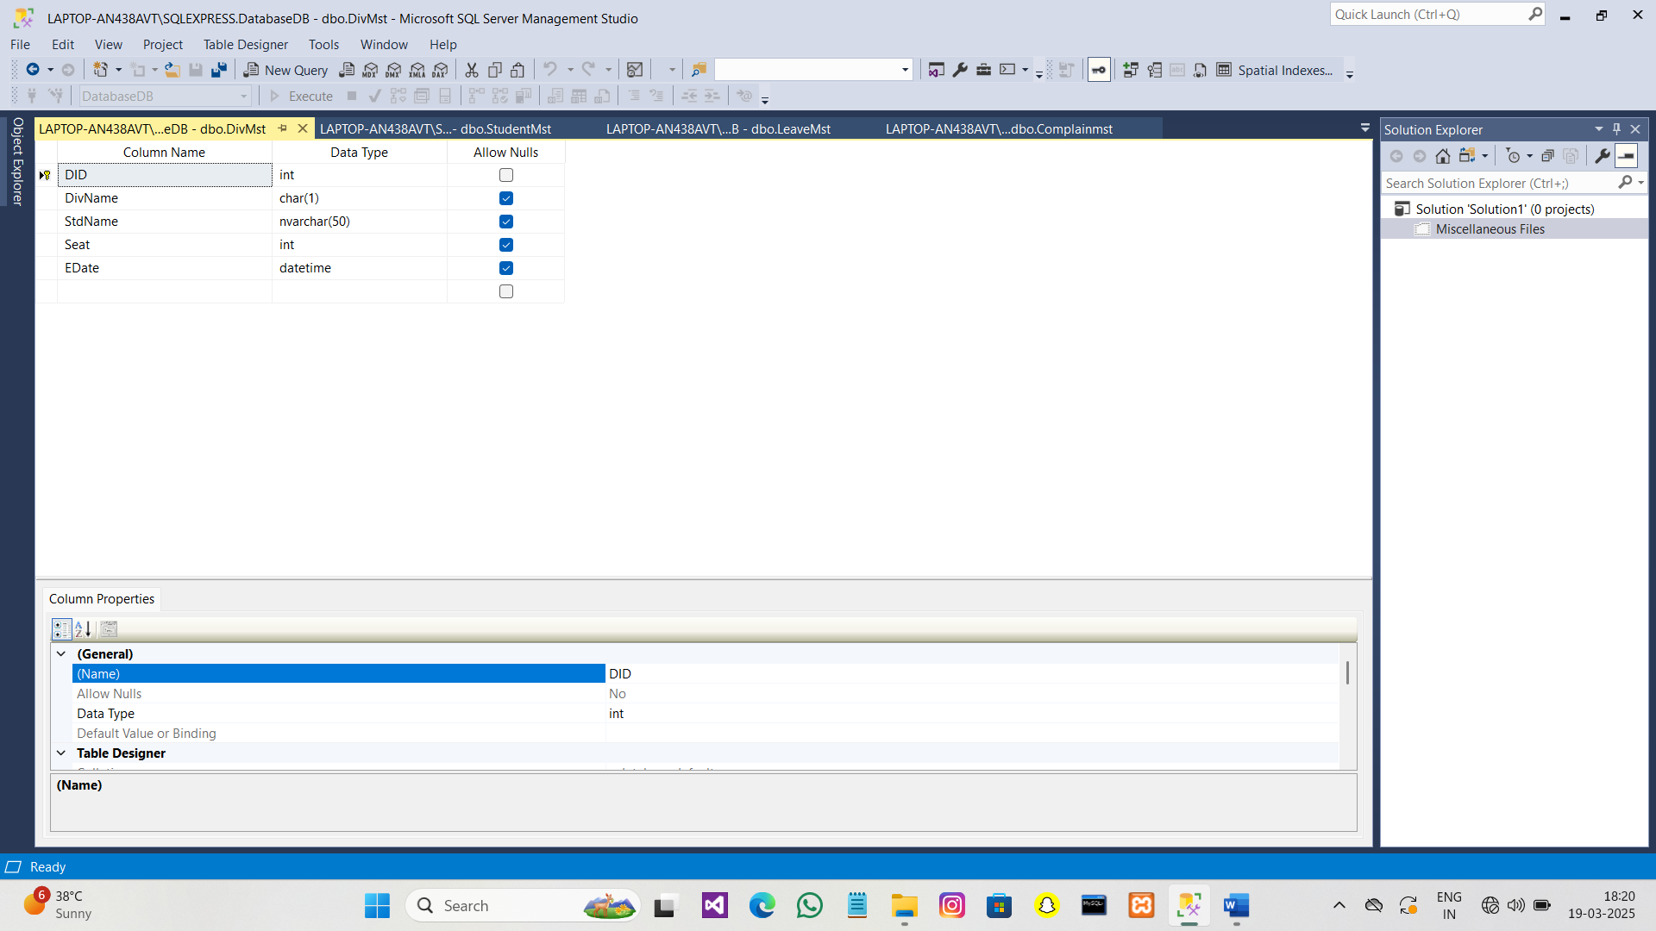

**Input design :-**

* Home Page :-

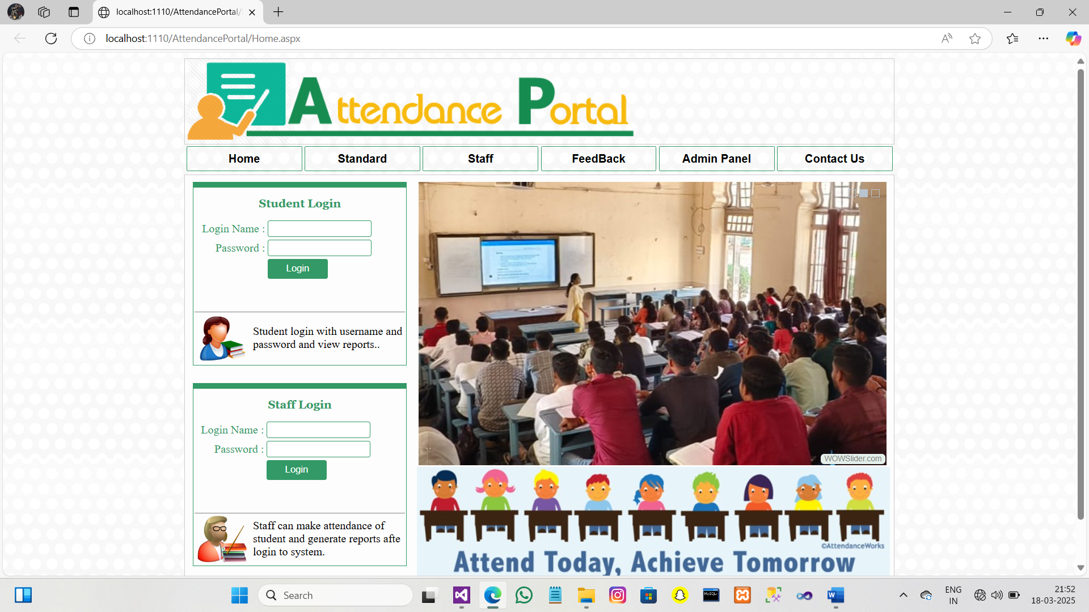

* Standard Page :-

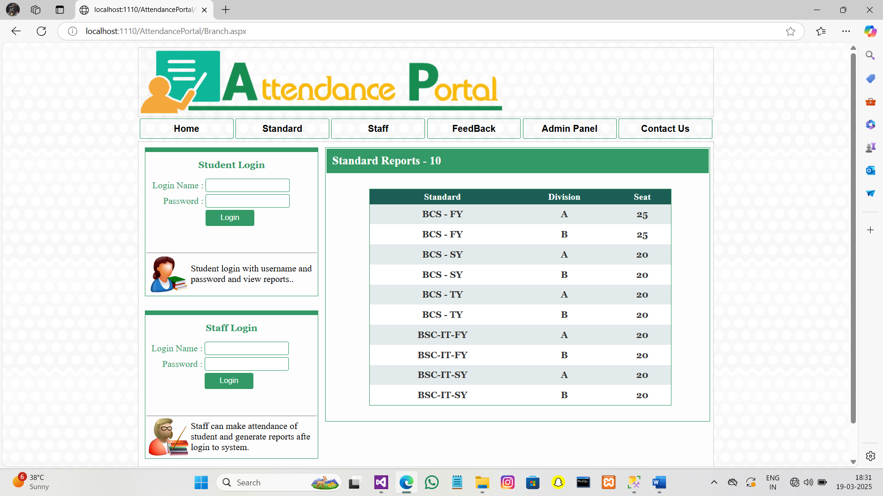

* StaffPage :-

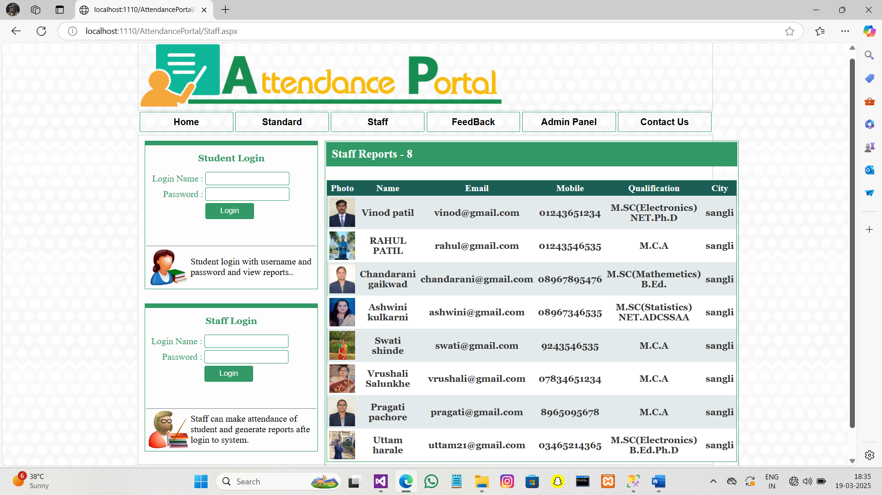

* Contact Us Page :-

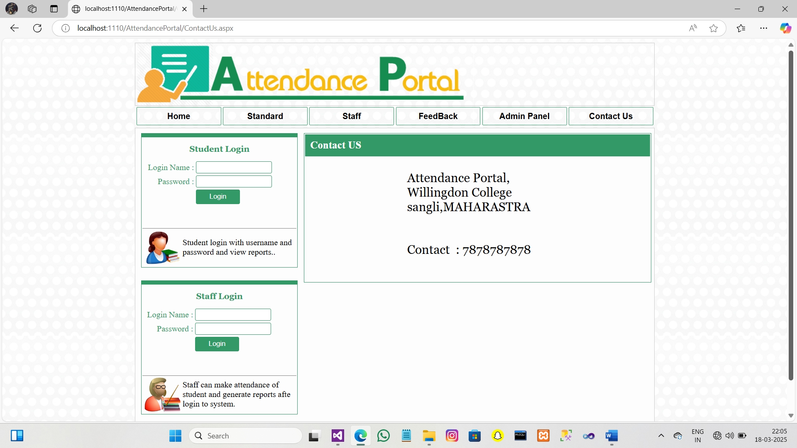

* FeedBack Page :-

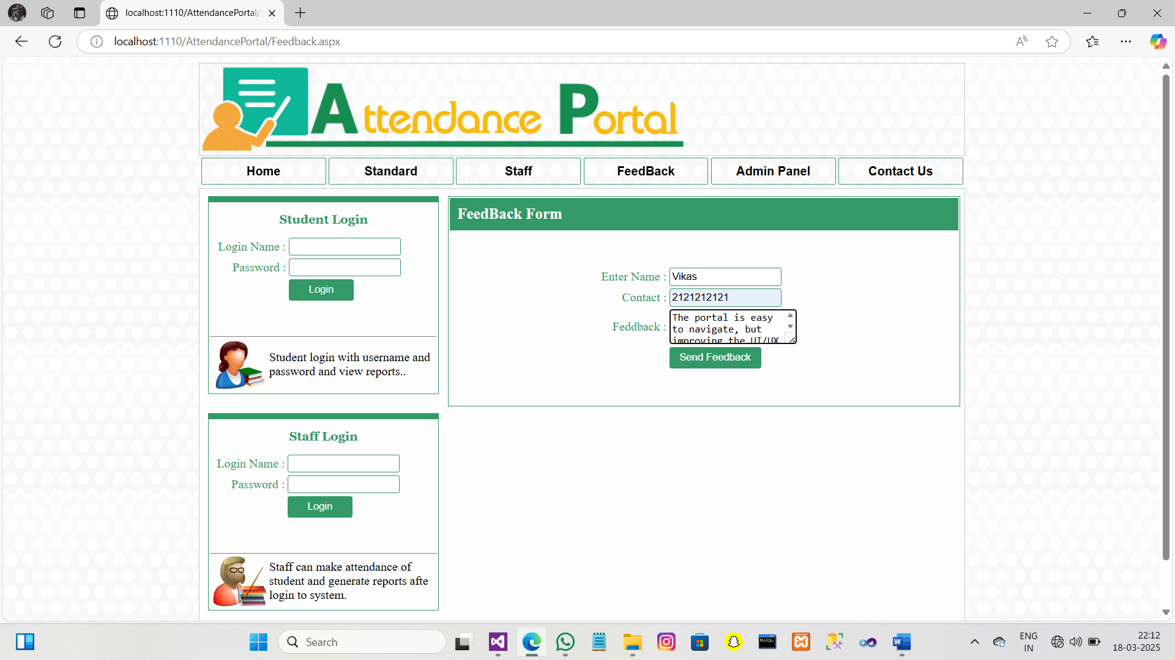

**Admin Login :-**

The Admin login provides principals or heads with access to manage staff, divisions, attendance records, and generate reports.

1. Admin Panel :-

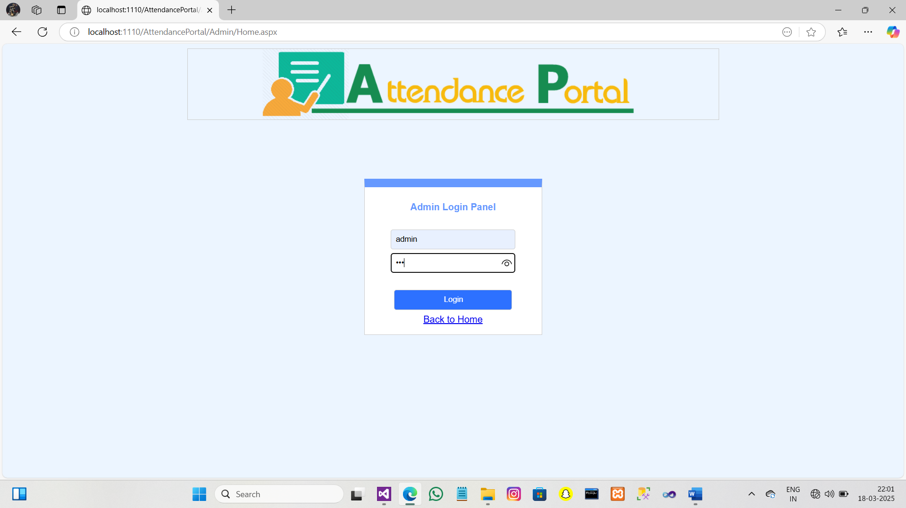

2.Add Standerd :-

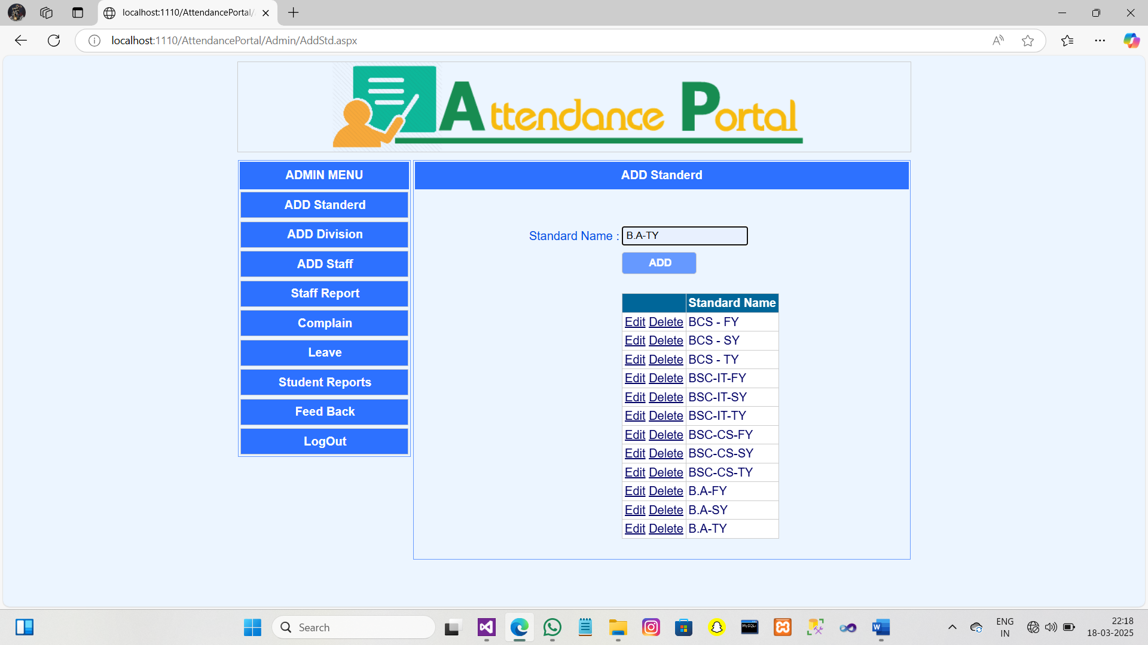

3.Add Division :-

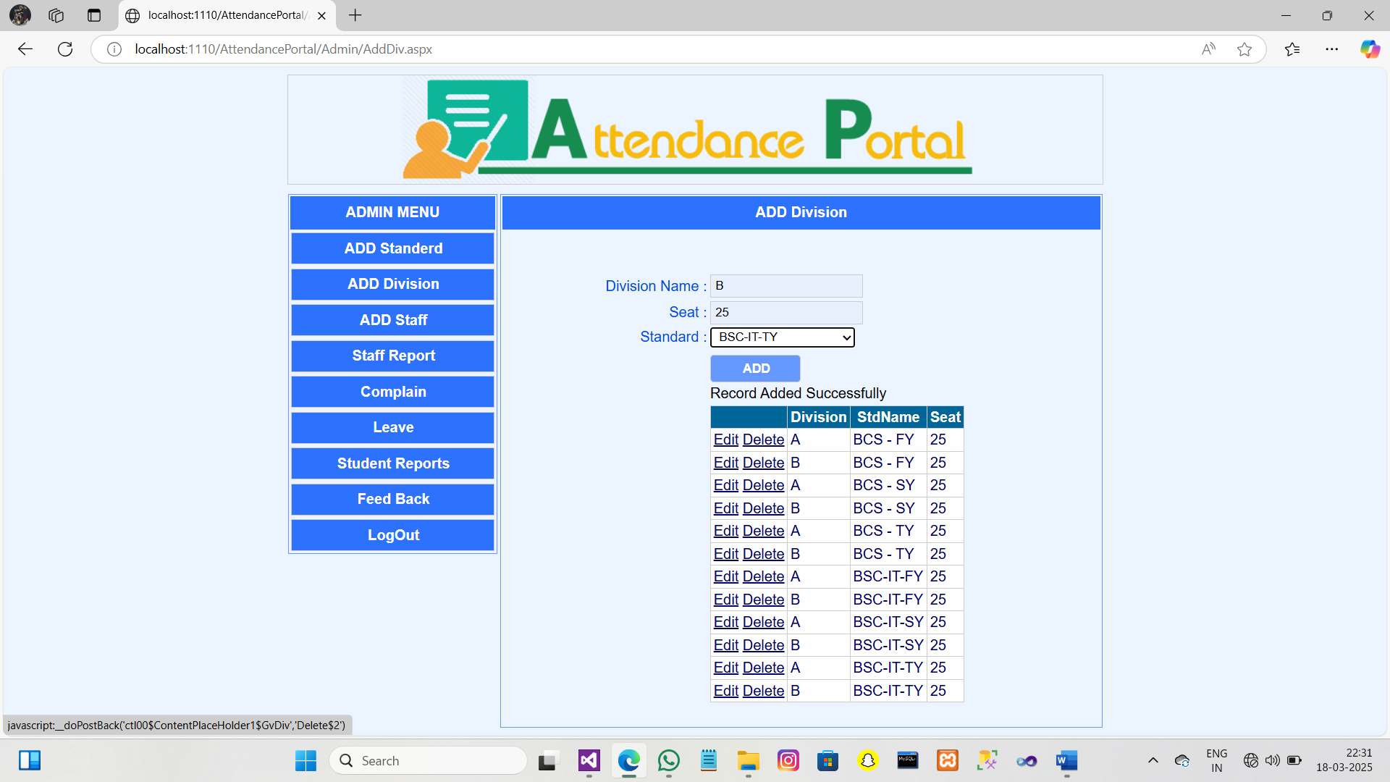

4,Add Staff :-

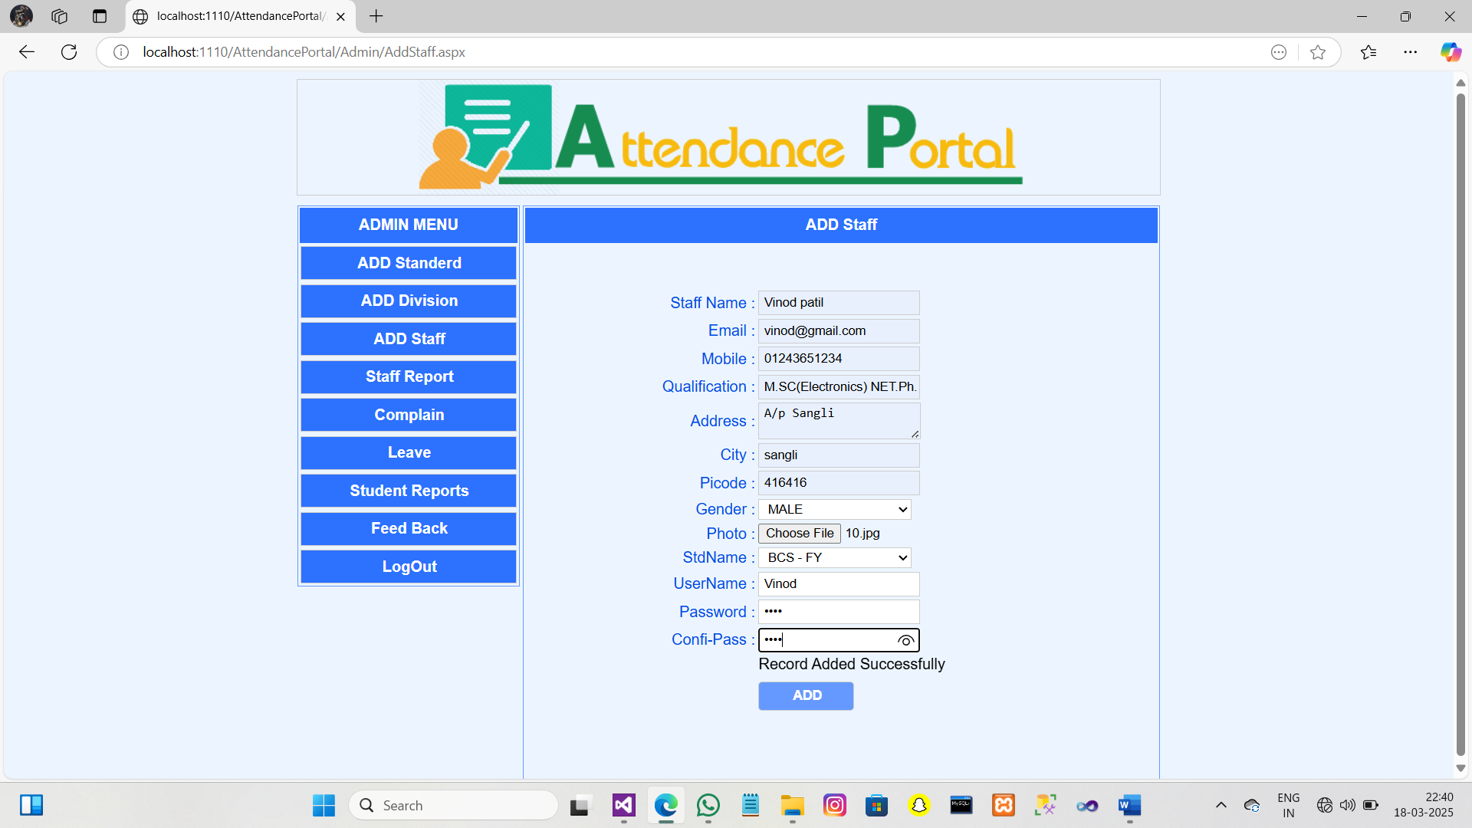

5.Staff Report :-

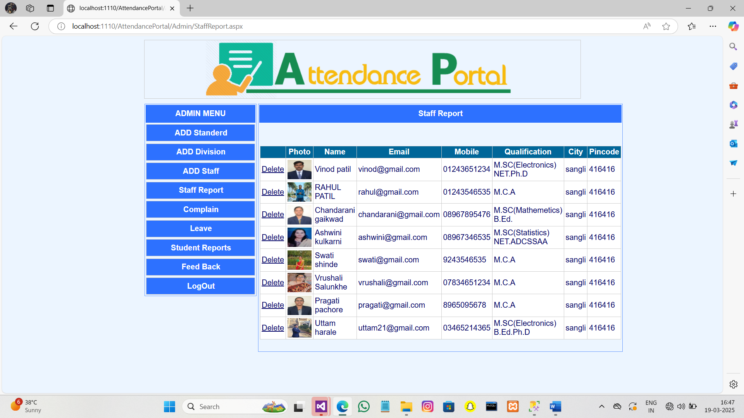

6.Leave :-

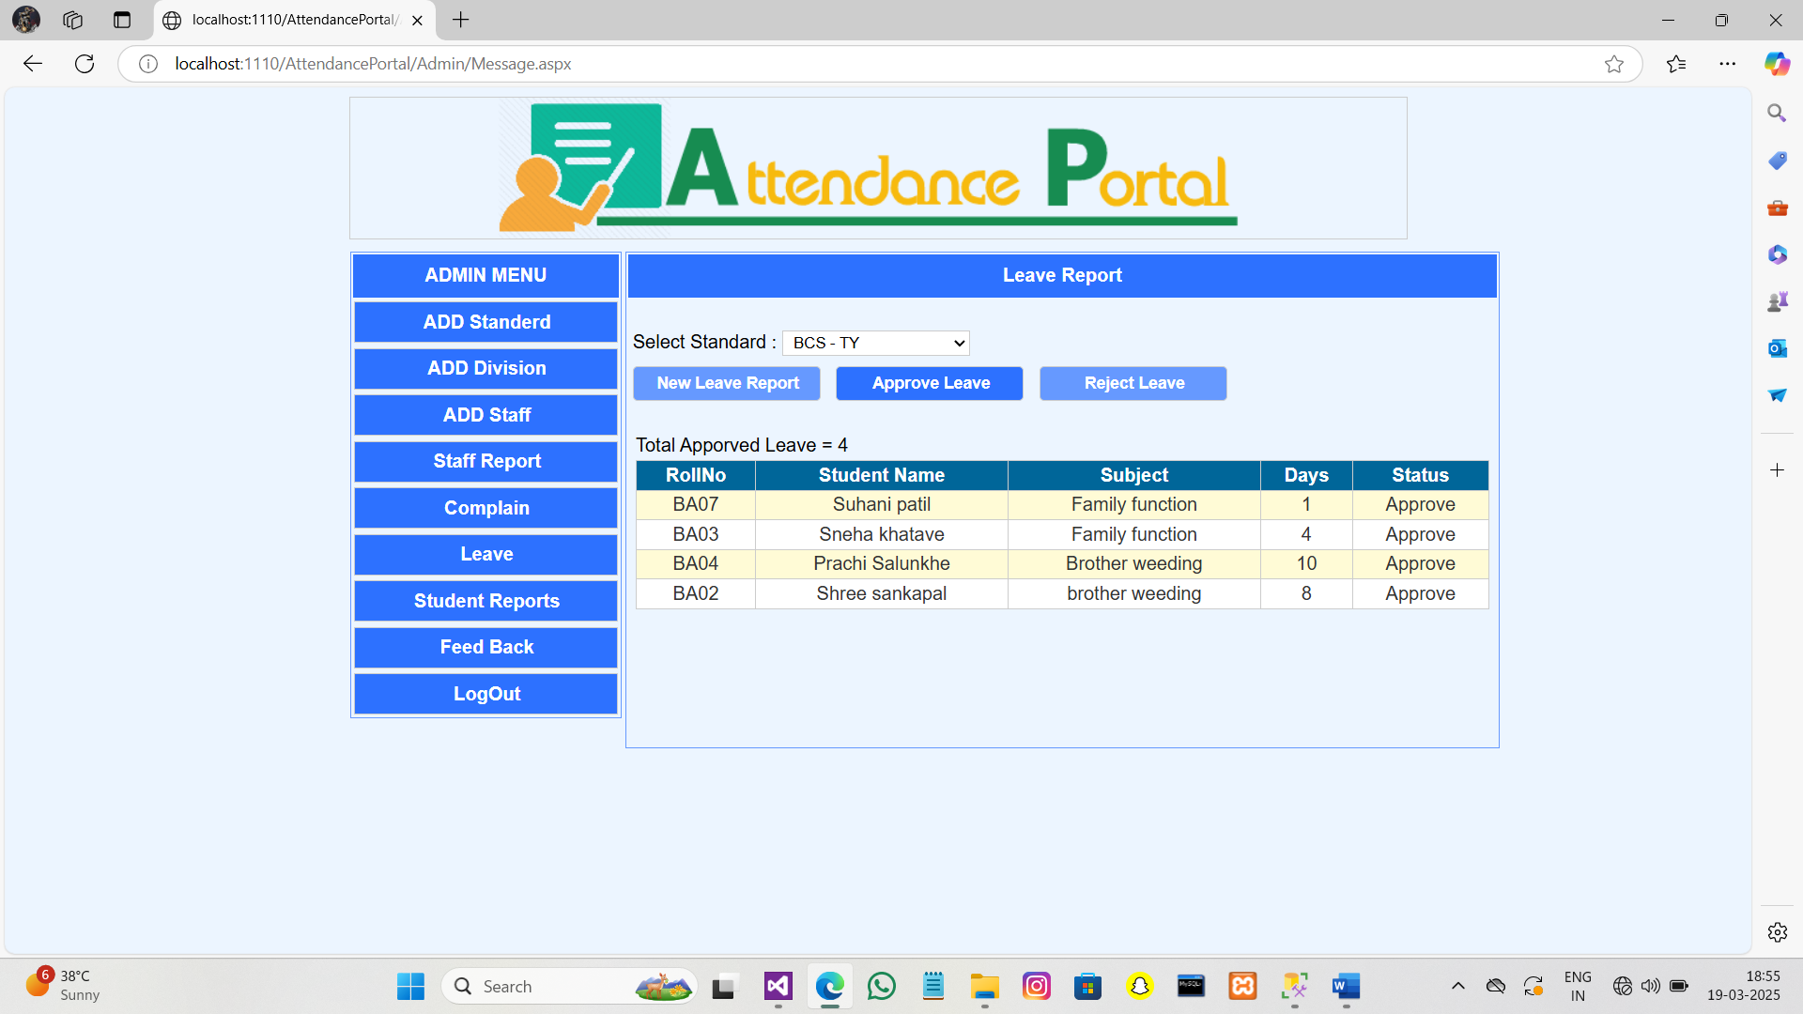

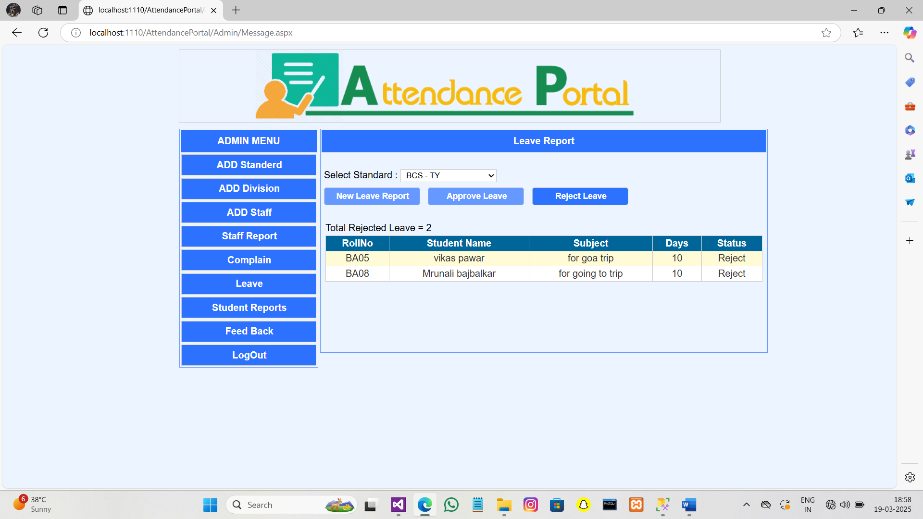

7.Student reports:-

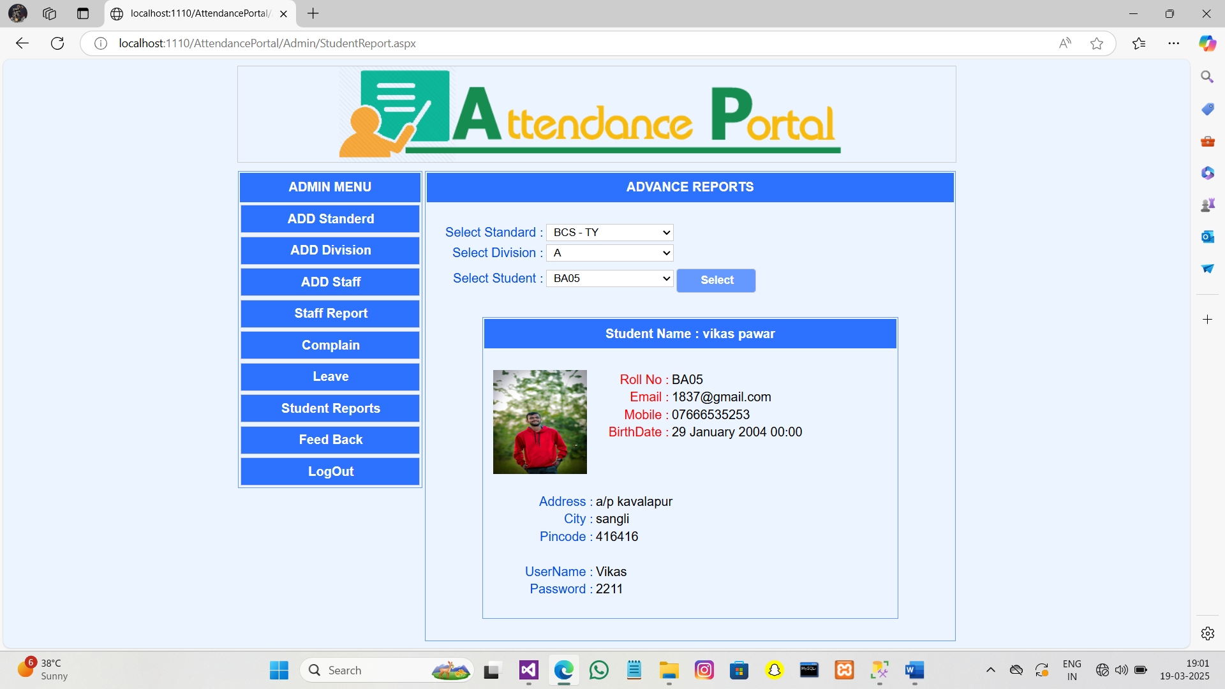

8.FeedBack:-

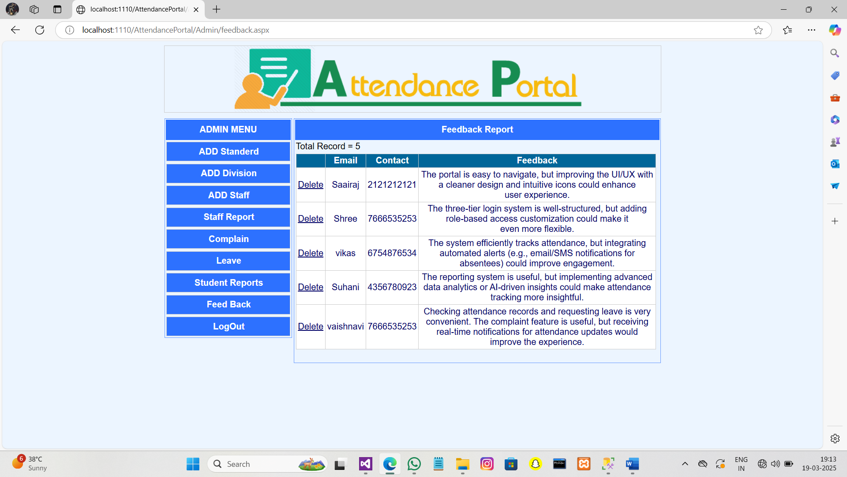

**Staff Login :-**

The Staff login allows teachers to manage student details, mark attendance, edit records, and generate attendance reports.

1.Staff_homepage :-

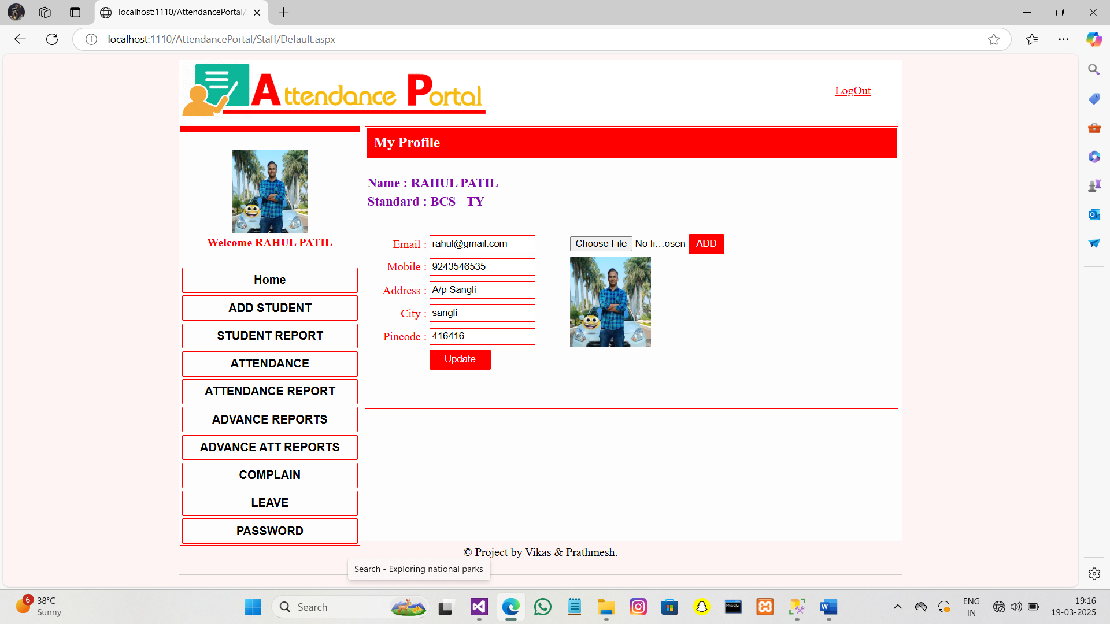

2.Add_student :-

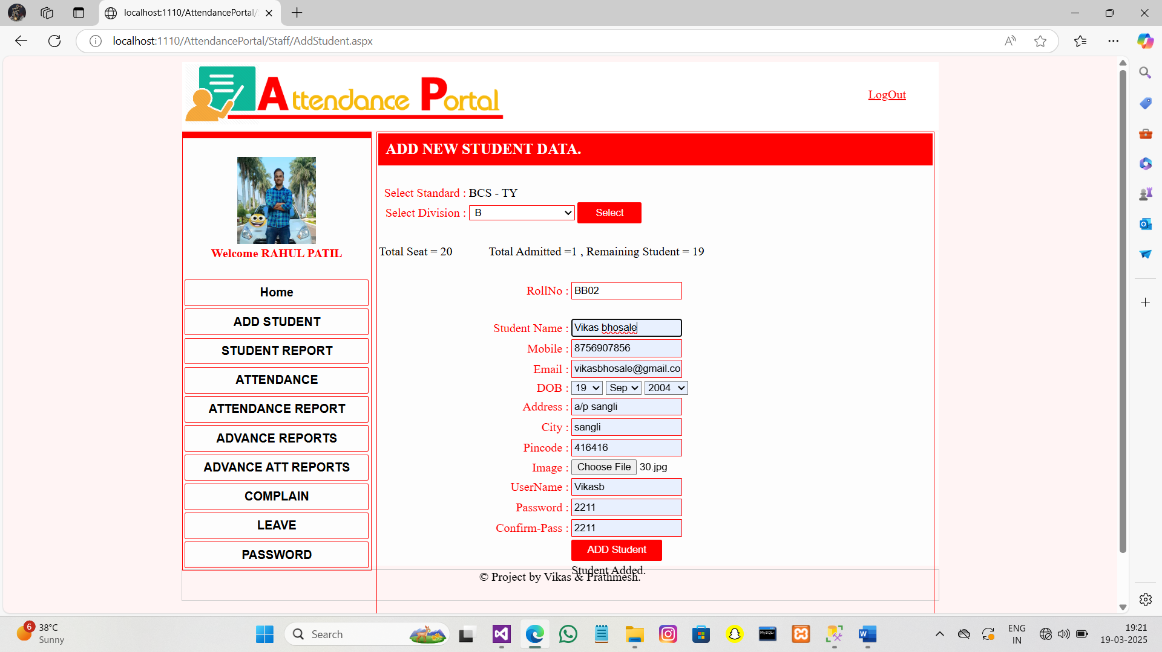

3.Student report :-

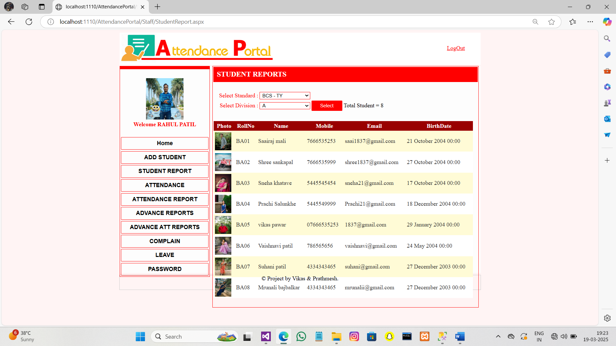

4.Attendence :-

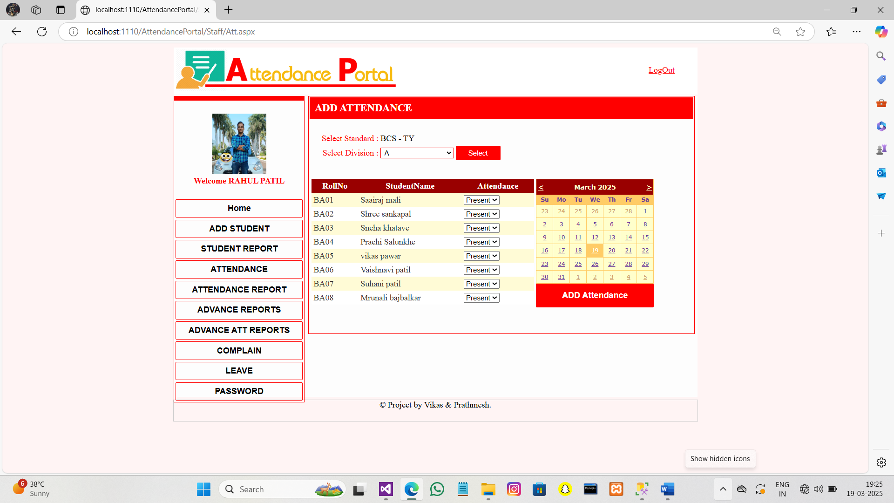

5.Attendence_reports :-

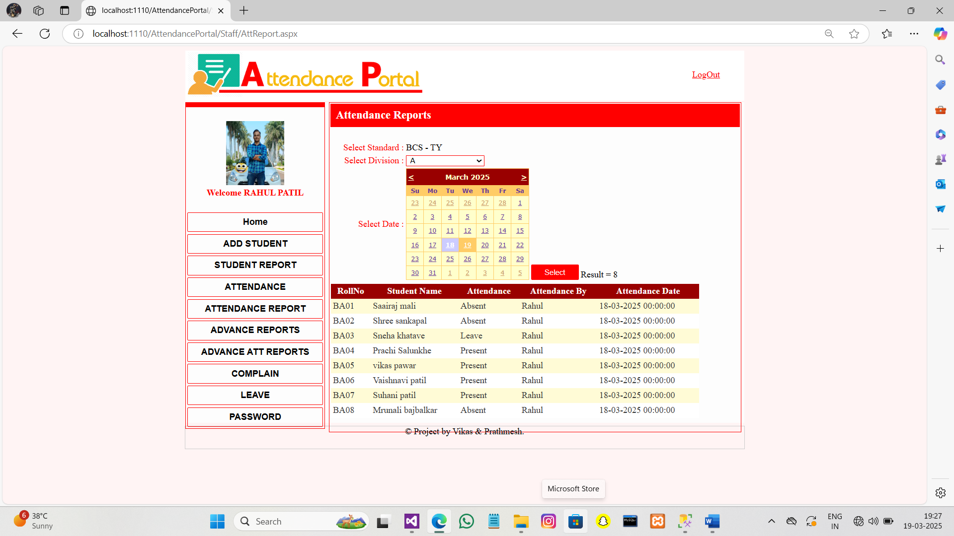

6.Advance_reports :-

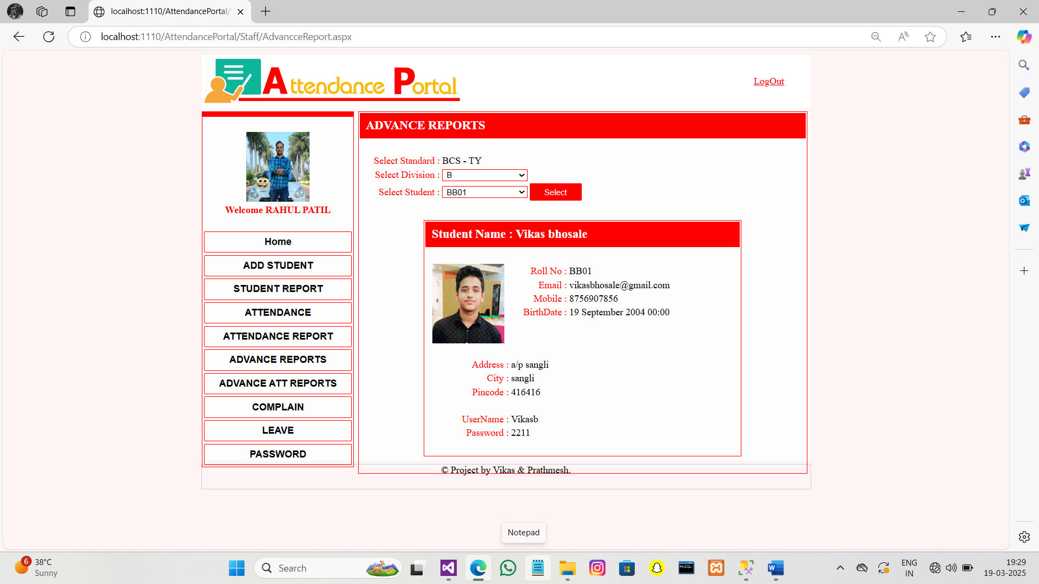

7.Advance_att_Reports :-

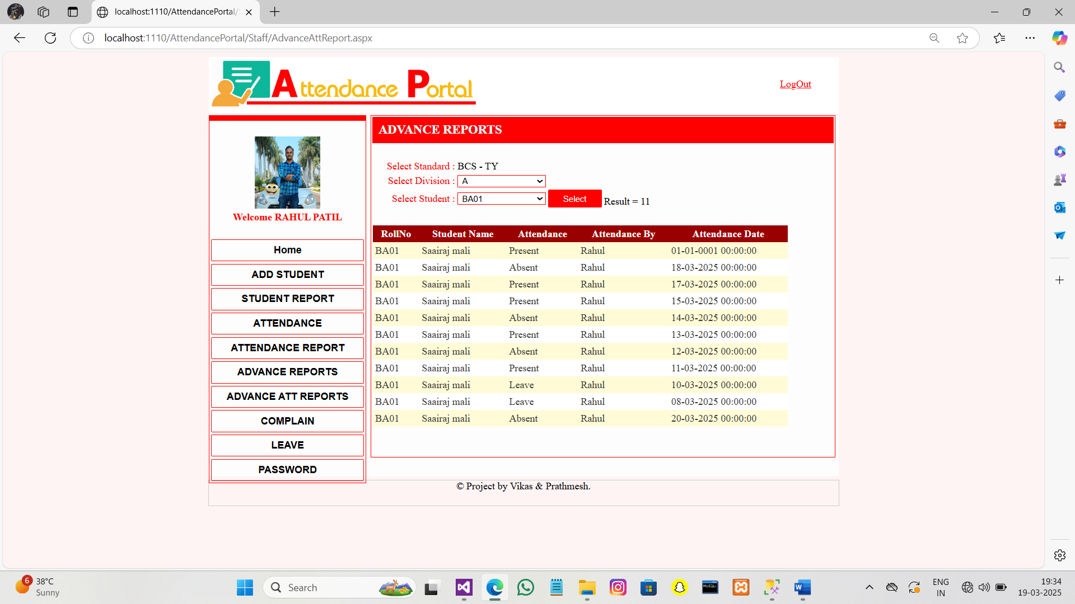

8.Leave :-

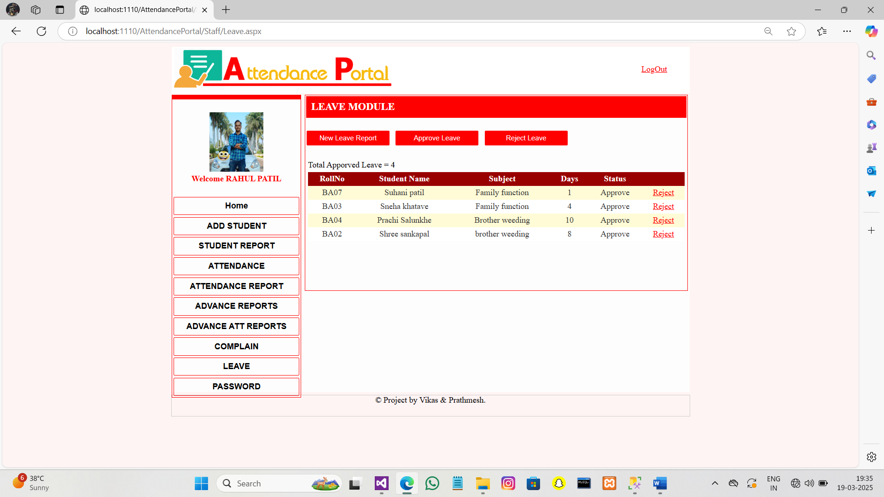

9.Password:-

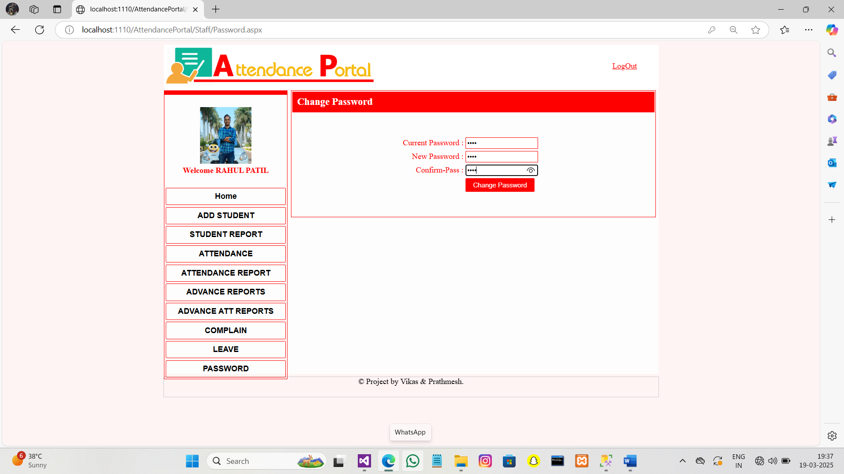

**Student_Login:-**

The Student login allows students to view attendance reports, submit leave requests, file complaints, and view or update image and details.

1.Home_page :-

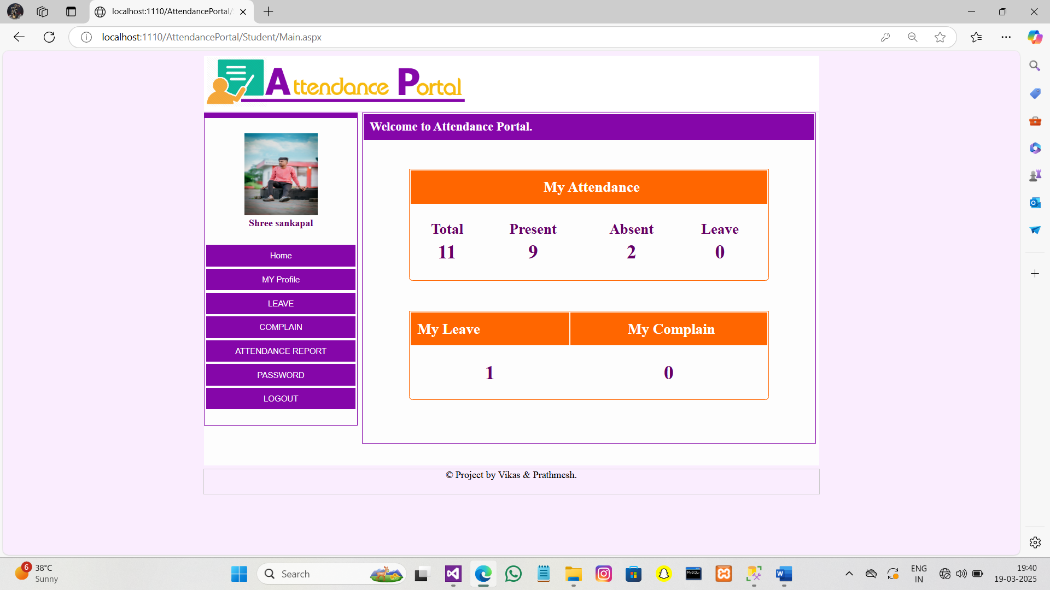

2.Student_Profile :-

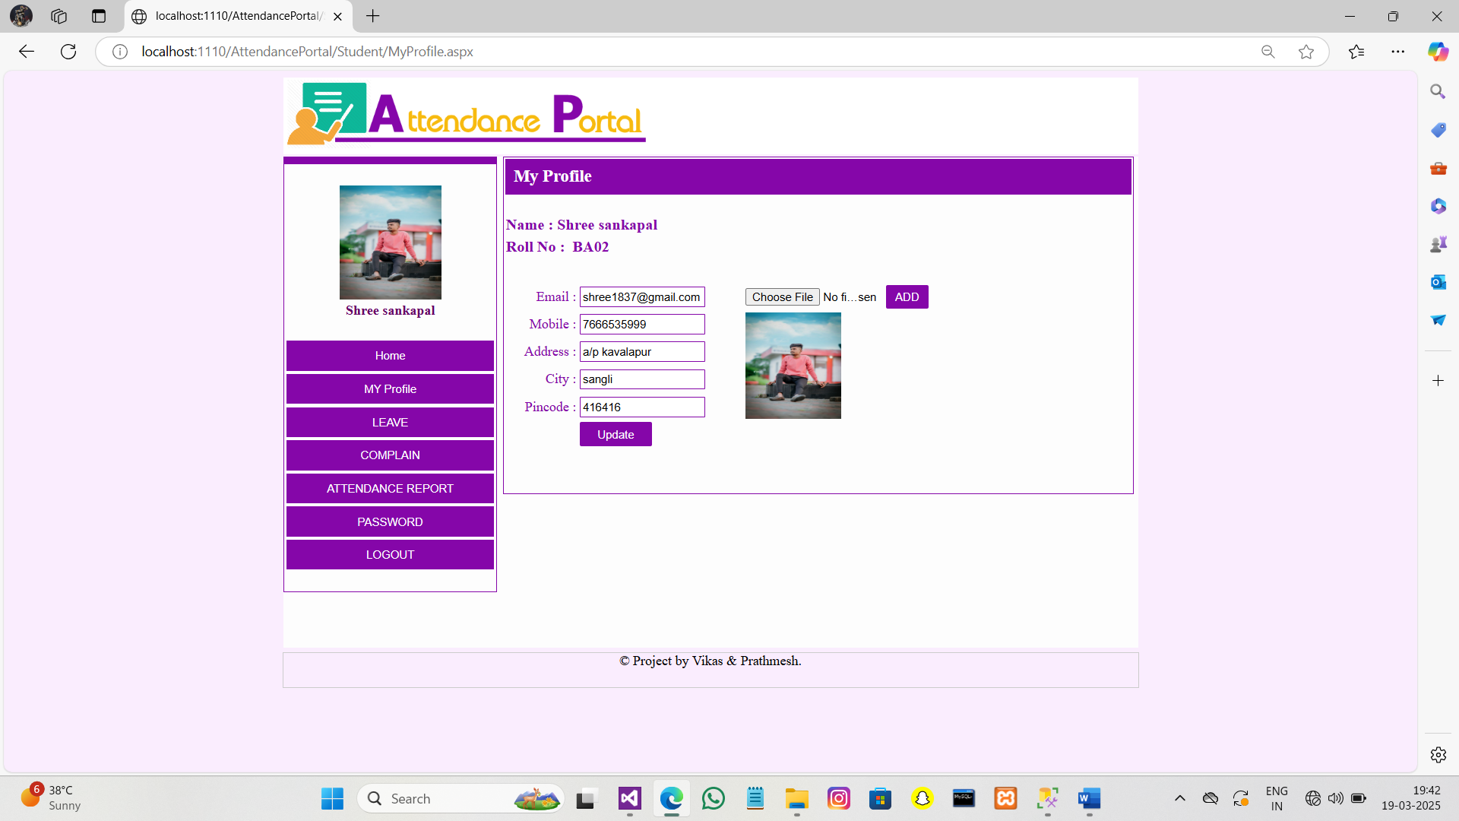

3.Leave :-

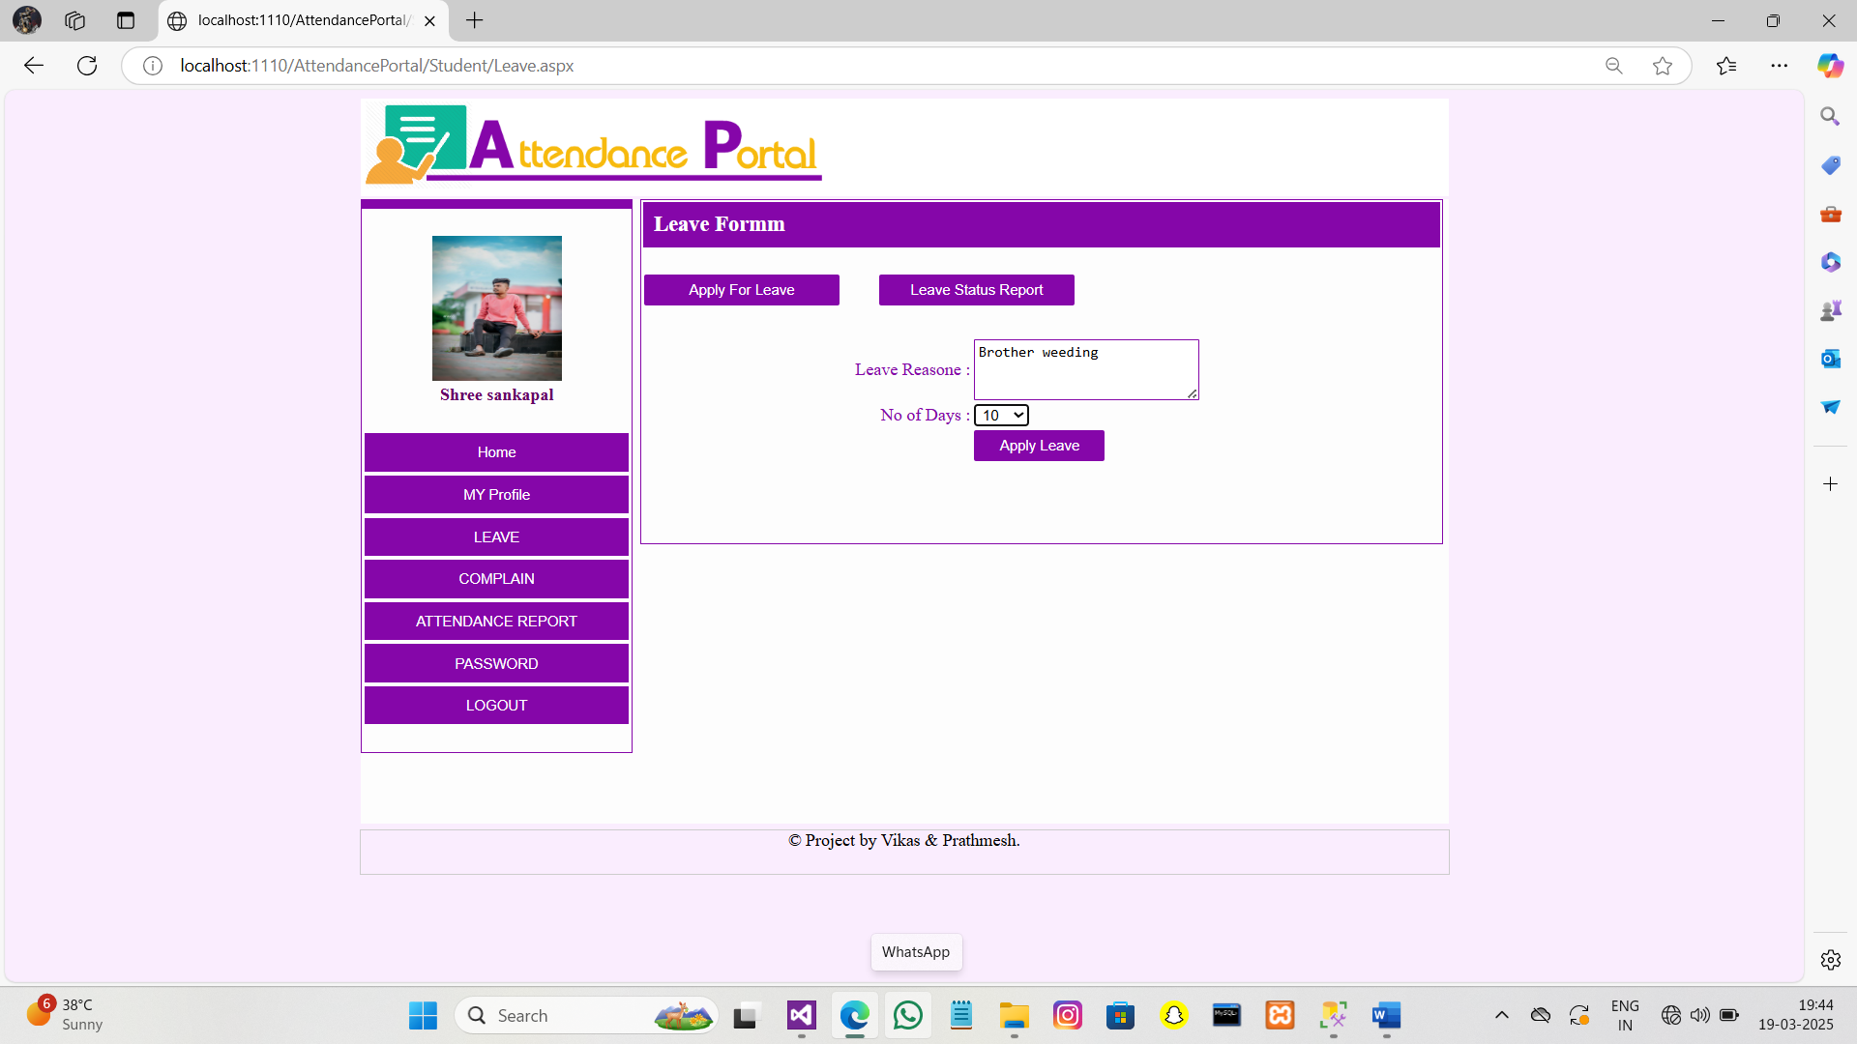

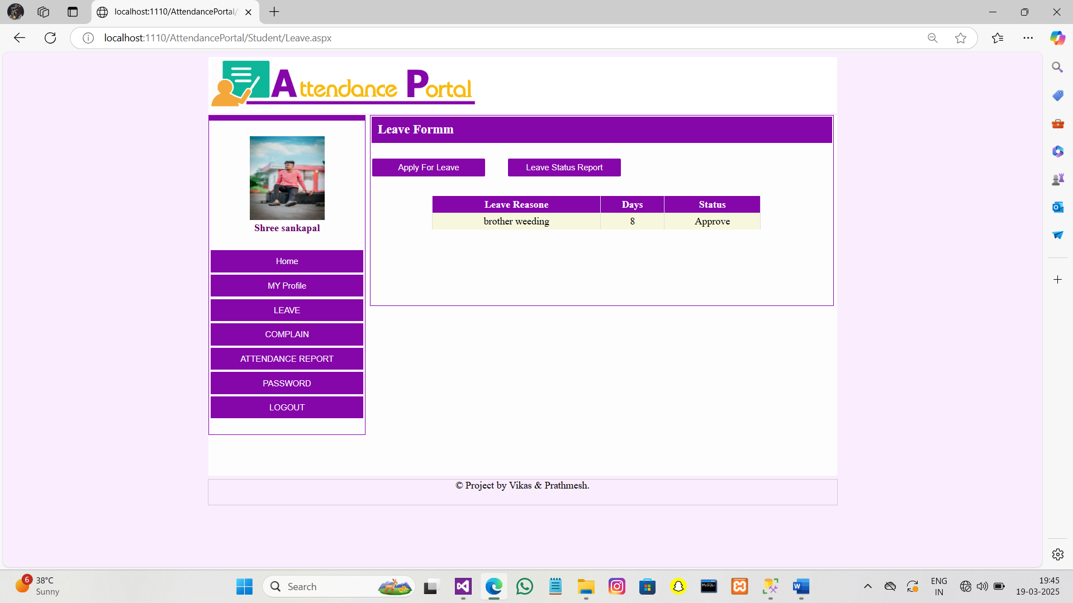

4.Attendence_Reports :-

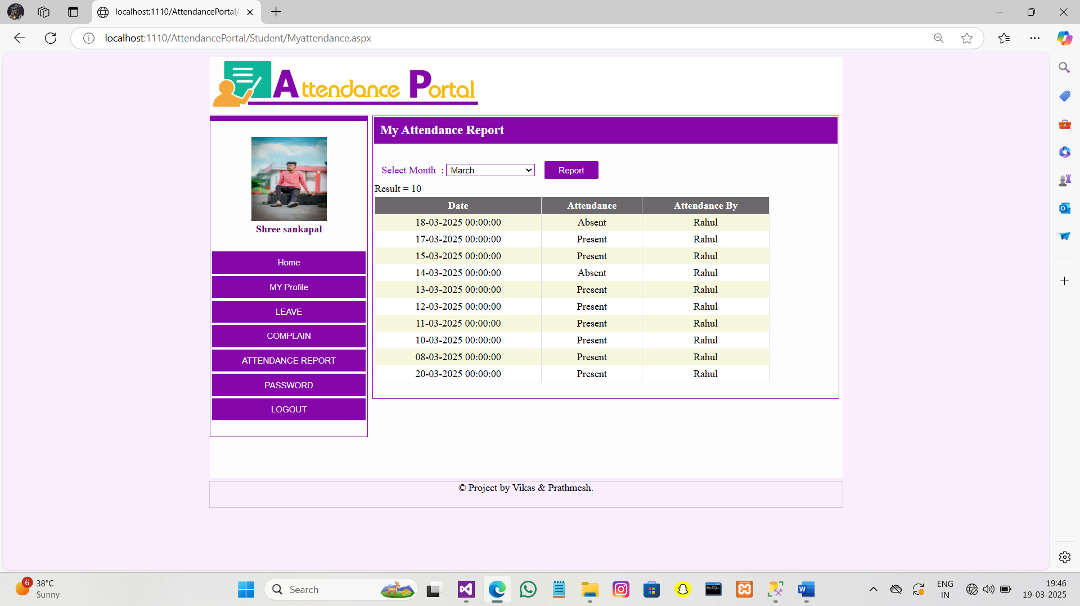

5.Password :-

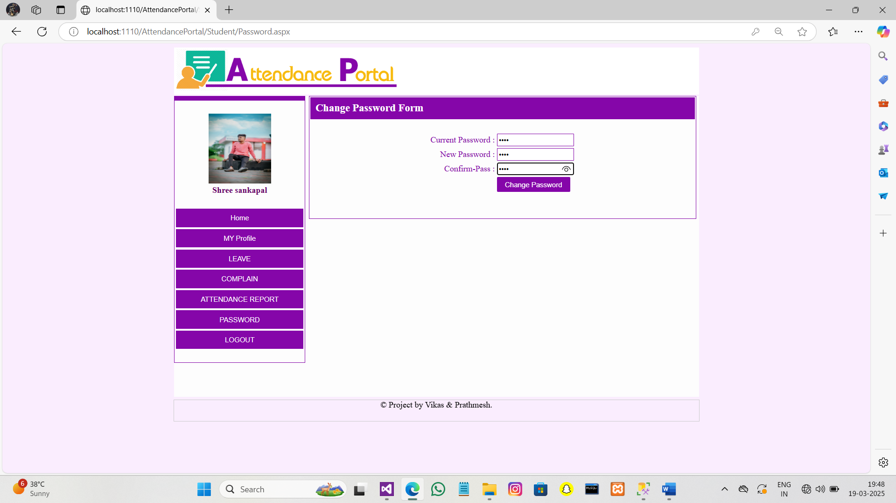

**REPORTS :-**

1. Standard Report :-

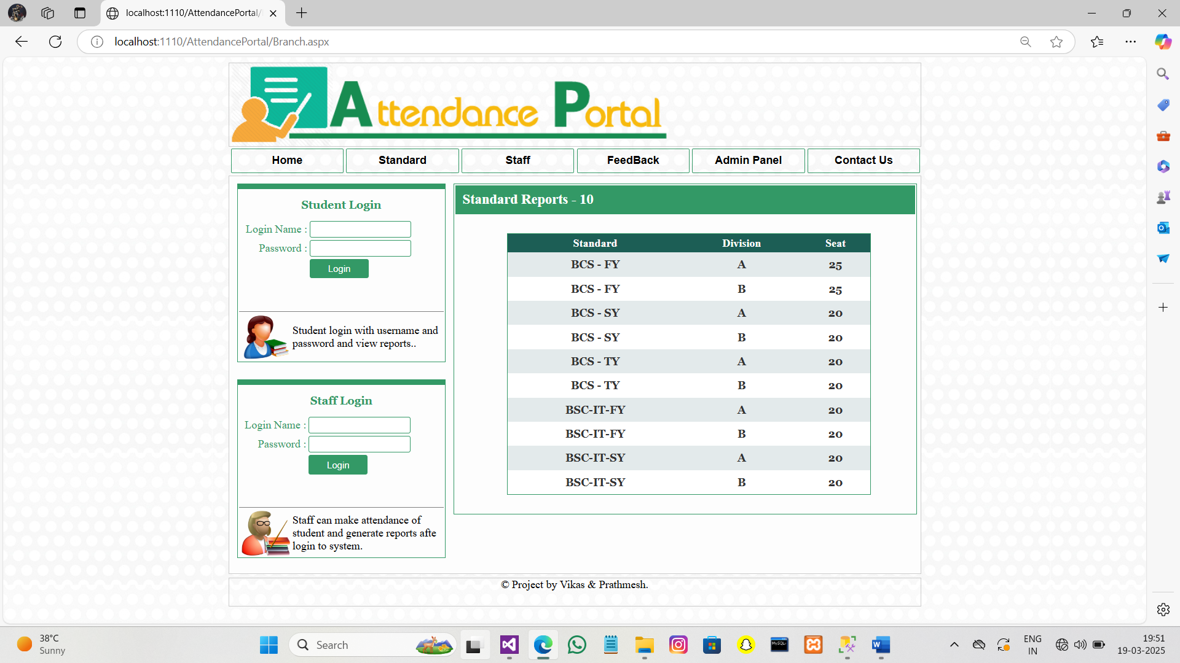

2. Attandance Report :-

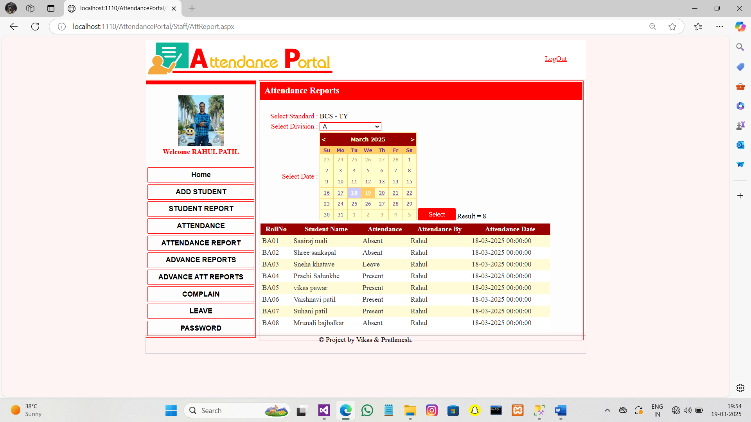

3.Staff Report :-

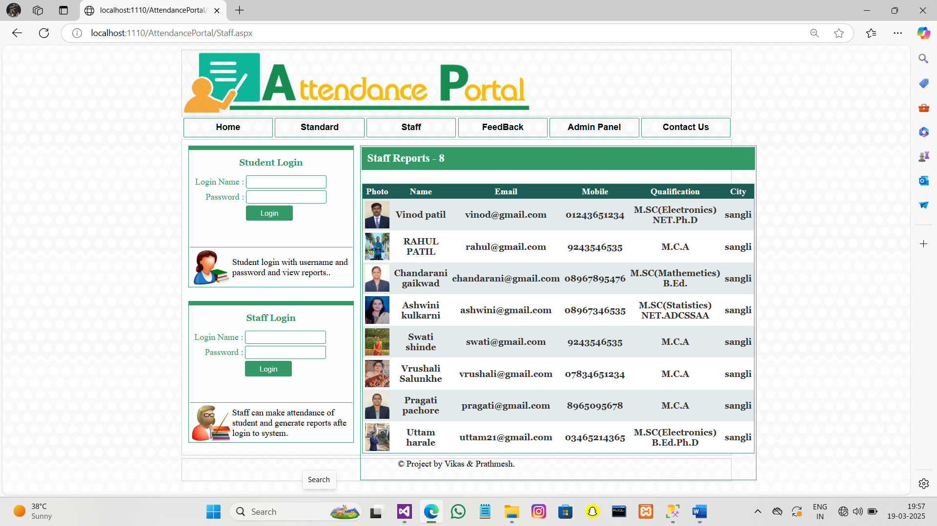

4.Student Report :-

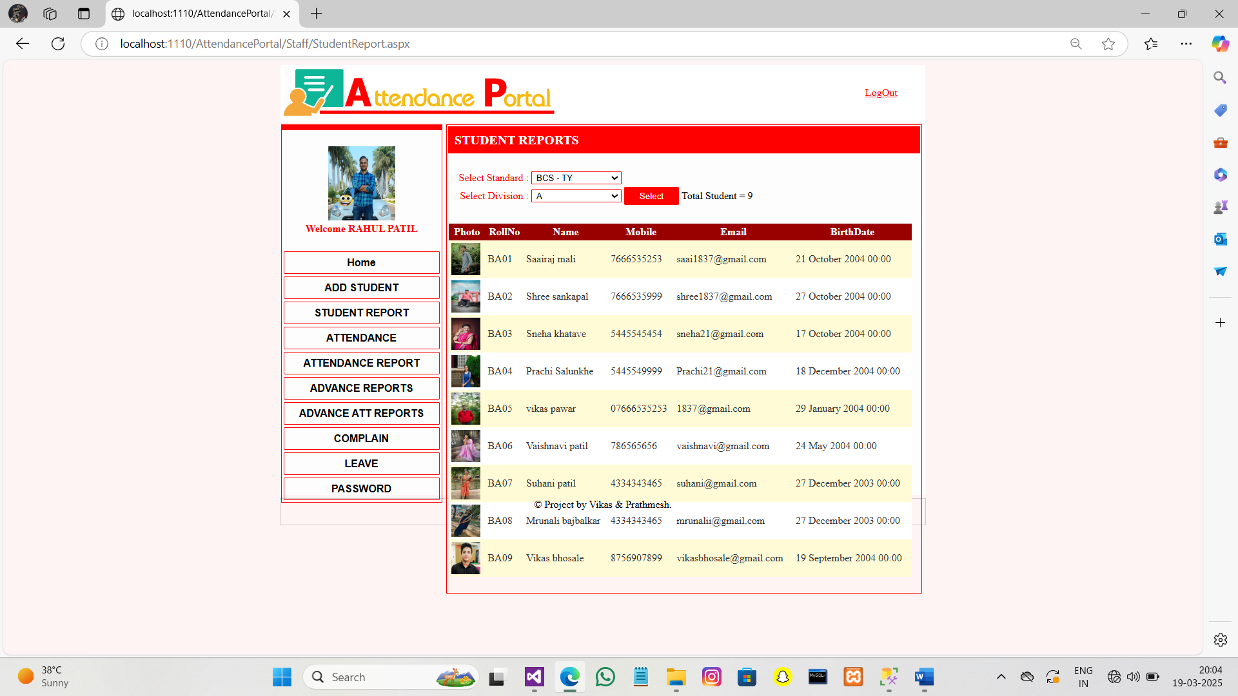

5.Leave Report :-

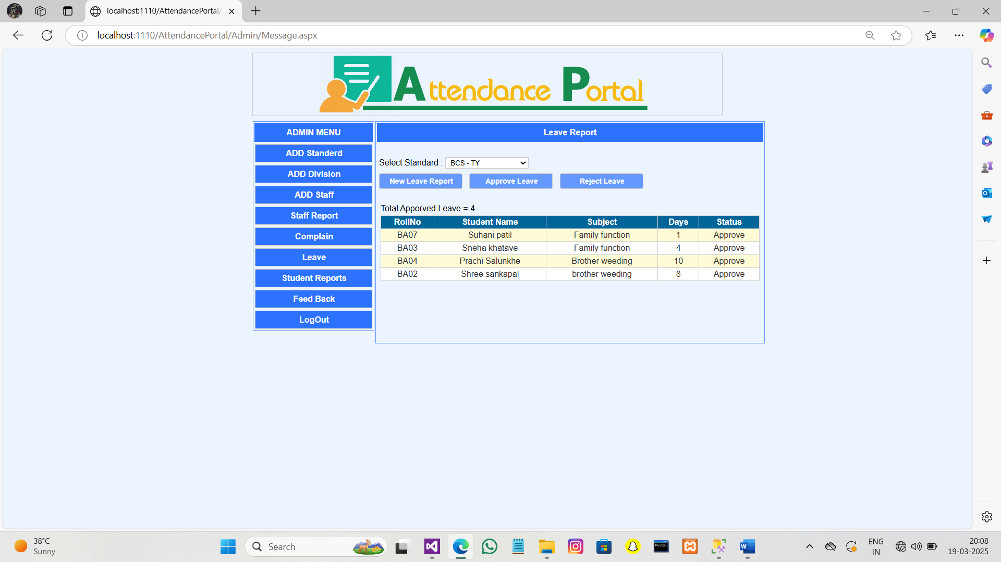

6.Feedback Report :-

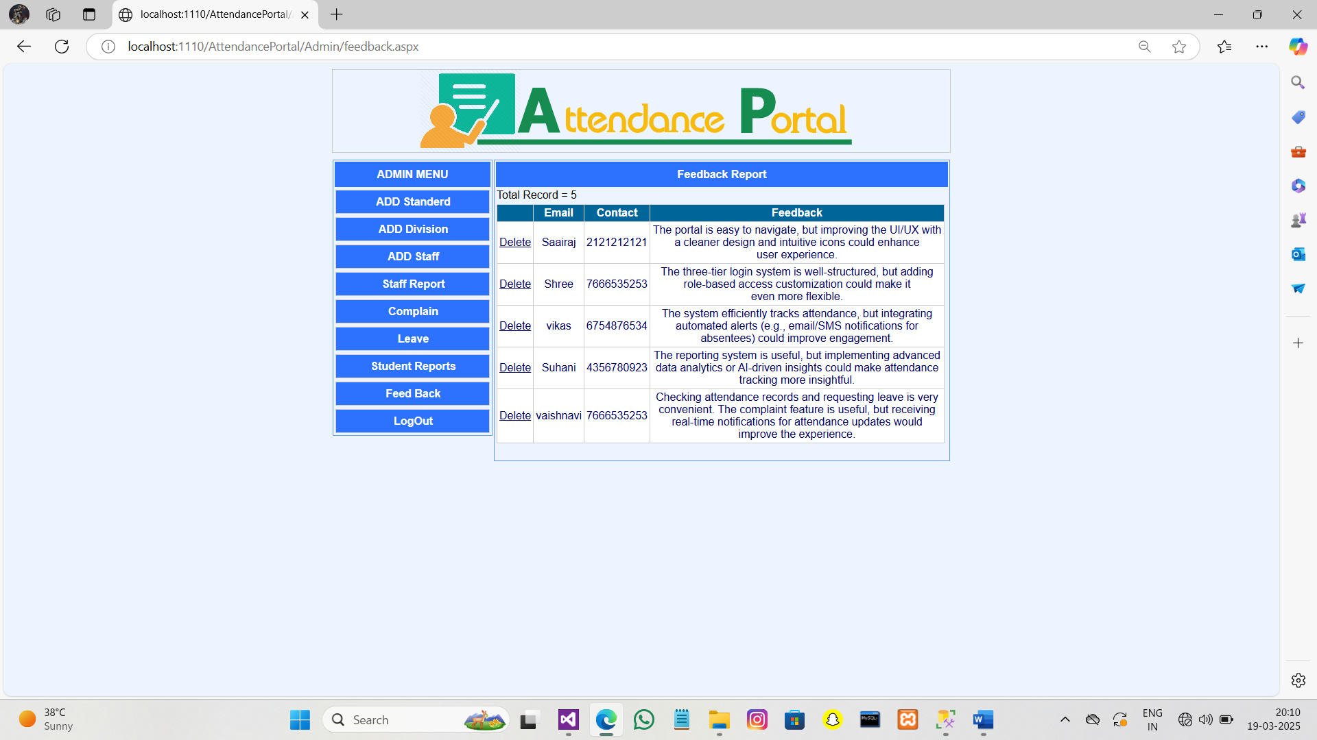

**Conclusion** :-

This paper assists in automating the existing manual system. This is a paperless work. It can be monitored and controlled remotely.

This portal is most useful for to fill up the student’s attendance online and maintain the student’s attendance on the daily basis. This portal reduce the paper work and saving time to generate accurate results. Finally Report of the student’s attendance on weekly and monthly basis is generated.

It reduces the man power required and provides accurate information. Malpractice can be reduced. All years together gathered information can be saved and can be accessed at any time. Therefore the data stored in the repository helps in taking decision by management. So it is better to have a Web Based system. All the student, faculty and management can get the required information without delay.

**Future enhancement** :-

Future enhancements for the Attendance Management Portal can include biometric or RFID-based attendance tracking to eliminate manual errors and ensure accuracy. A mobile application can be developed to provide students, staff, and admins with real-time access to attendance records, leave requests, and complaint statuses. Integration with SMS and email notifications can help keep students and parents informed about attendance status and important updates. Additionally, multi-language support can be added to improve accessibility for a diverse user base. Enhanced data security measures, such as role-based access control and encrypted data storage, can further protect sensitive information.

**BIBLIOGRAPHY :-**

* **Refrences**
* **Books References** ASP.Net with C# by Shyam n Chavda & ASP.Net 3.5 Black Book .
* Introducing Microsoft .NET, Second Edition author David S. Platt.
* Alex Mackey Introducing .NET 4.0: With Visual Studio 2010, Press, USA, 2010.
* During the development of our system,we have taken the reference from various books and journ also, which we would like to mention in this section.
* **WEBSITES**
* http://www.msdn.net/
* http://www.w3schools.com
* http://www.dotnetspider.net
* http://www.codeproject.com